

Add Organisation Staff
  - Task Card
This guide explains how an Organisation Administrator can add staff members to the Grant Recipient Portal (Portal) and assign the appropriate access level.
Portal access required: Administrator.

Quick Links
Understanding Access Levels
Add Staff in the Portal
Need help?

Understanding Access Levels
Before adding a staff member, decide what level of access they need.
Administrator
Administrators have the highest level of access. They can:
- Manage staff access
- Create and edit staff records
- Update organisation details
- Update their personal profile
- Request bank account updates
- Submit reports and acquittals
- View grant information
- View and resend payment advice
Editor
Editors can:
- Submit reports and acquittals
- Update their personal profile
- View grant information
- View and resend payment advice
Viewer
Viewers cannot make changes to organisation information or submit reports. They can:
- View grant information
- Update their personal profile
- View and resend payment advice
No Access
Use No Access for staff who do not need Portal access but still need to be recorded as an organisation contact and assigned to grants or activities.

Add Staff in the Portal
From the Portal home page, select the Organisation Profile tile, or link from the navigation menu.
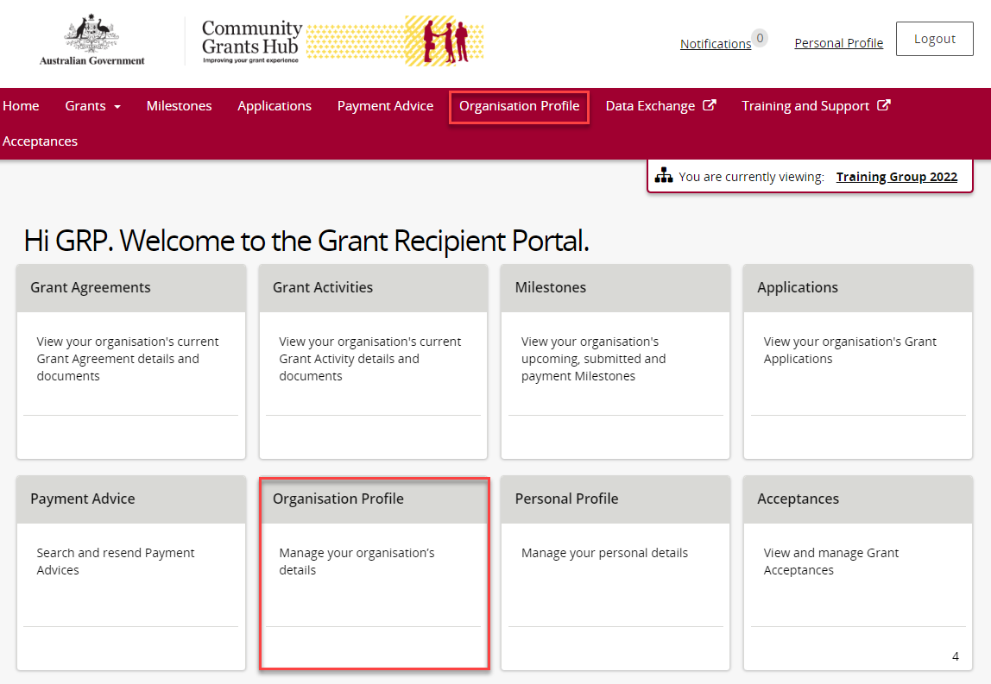
The Organisation Profile page opens.
Select Staff from the Organisation Profile menu.
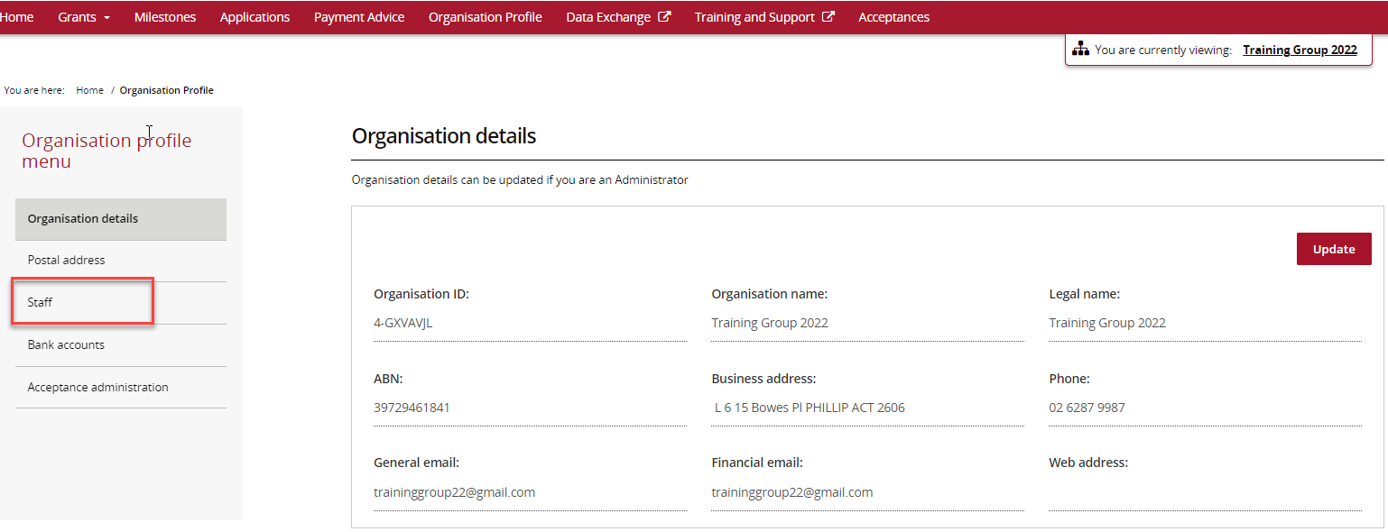
The Staff page displays active staff members by default.
You can filter the list to view:
- Active Staff
- Inactive Staff
- All Staff
Each staff member has a unique Contact ID that can help identify records and avoid duplicate contacts.
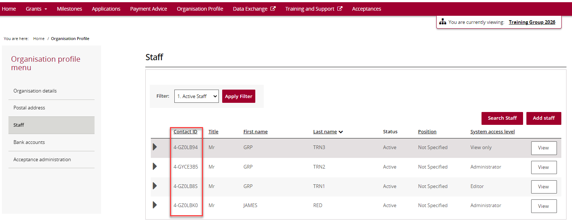
Select Add staff.
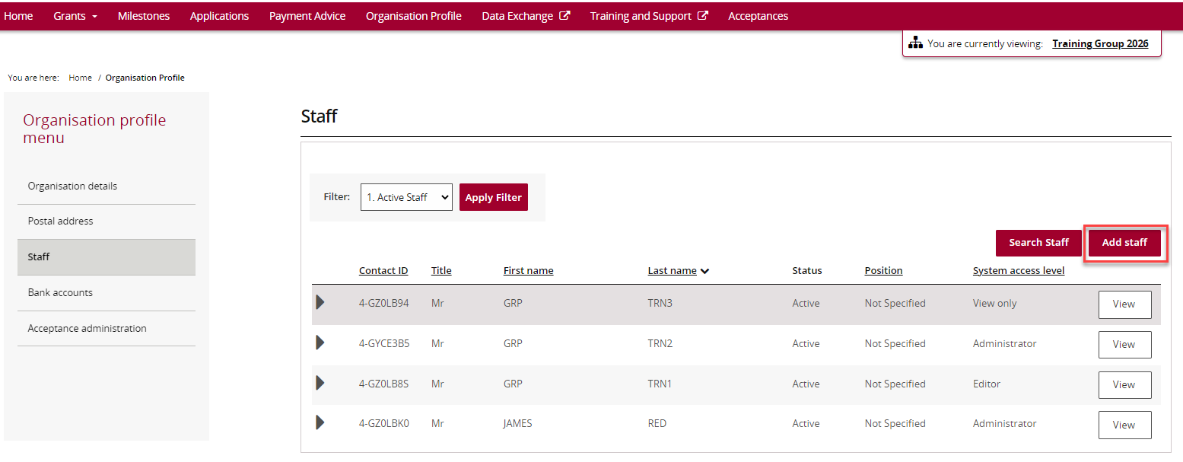
Complete the required details for the new staff member.
Required fields are marked with a red asterisk (*).
Enter:
- Title
- First name
- Last name
- Position
- Email address
- Phone number (if applicable)
- Required system access level
Choose the most appropriate access level based on the staff member’s role.
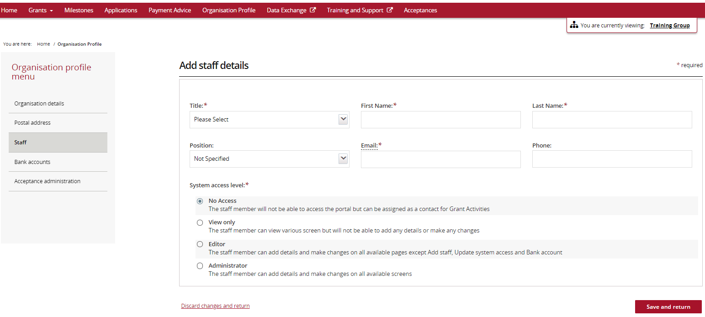
When all information has been entered, select Save and return.
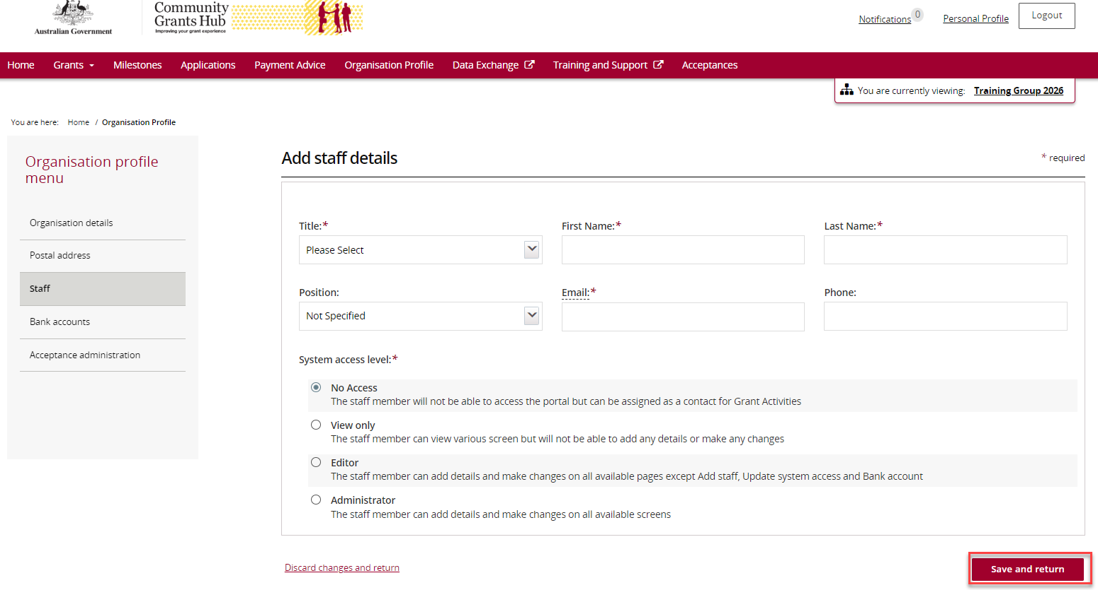
The system automatically checks for duplicate contacts before saving.
Exact Match Found
If the First Name, Last Name and Email Address match an existing contact for your organisation, the system will display an error, and the contact cannot be added.
Matching Email Address Found
If the email address already exists for another contact, but the name is different, a warning message will appear.
You can:
- Select Continue to create the new contact, or
- Select Discard changes and return to cancel.
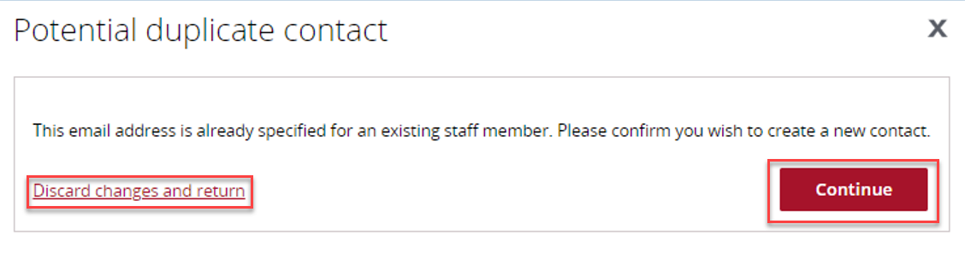
If the contact is successfully created, a confirmation message appears briefly on screen.
The new staff member will then appear in the Staff list.
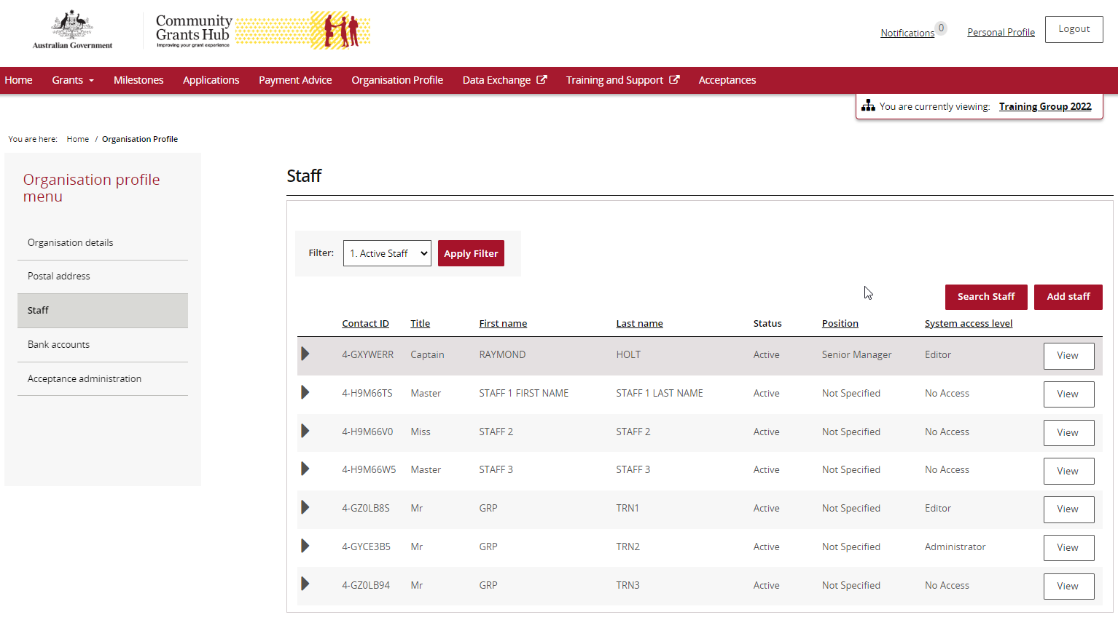

Need help?
For further assistance with the Grant Recipient Portal, please contact the Community Grants Hub at GRP.Helpdesk@communitygrants.gov.au.

