

Reactivate and Inactivate Organisation Staff
  - Task Card
The Grant Recipient Portal (Portal) enables grant recipients to reactivate and inactivate their organisation staff records. This task card describes the process of reactivating and inactivating organisation staff records in the Portal.
Portal access required: Administrator

Quick Links
What do Active and Inactive Staff mean?
Open a Staff Record
Reactivate a Staff Record
Inactivate a Staff Record
Need help?

What do Active and Inactive Staff mean?
- Active staff are current organisation contacts in the Community Grant Hub’s Grant Payment System with no end date.
- Inactive staff are former organisation contacts who have an end date recorded in the Community Grant Hub’s Grant Payment System.
- The Portal will not show the end date.

Open a Staff Record
From the Portal home page select the Organisation Profile tile, or link from the navigation menu.
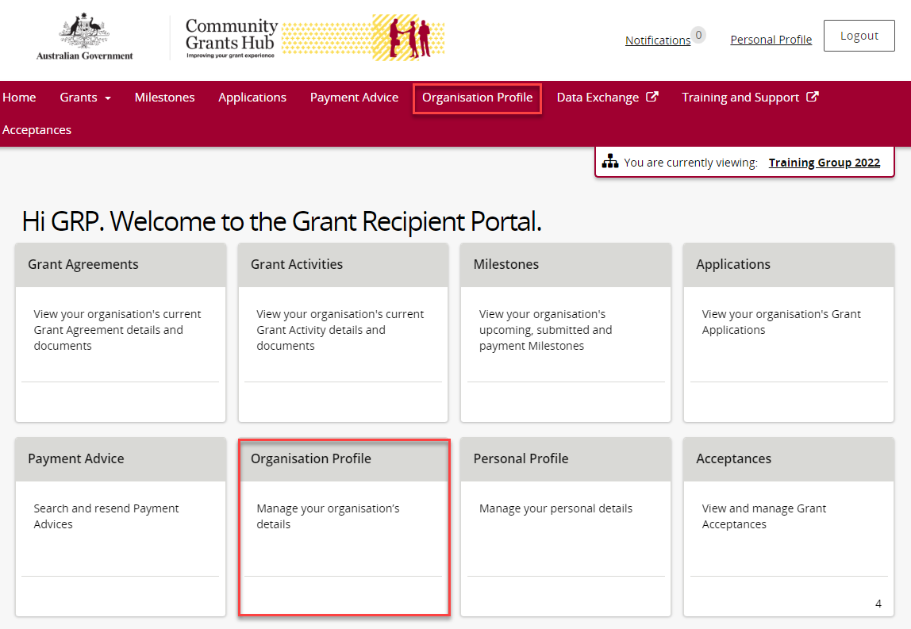
On the Organisation Profile page, select Staff from the menu on the left.
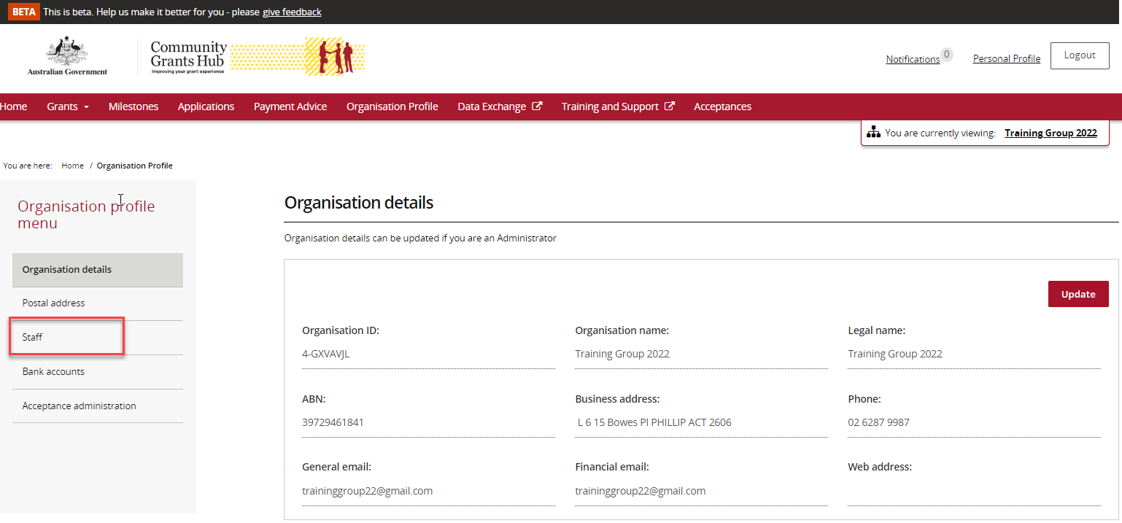
The Staff screen opens and shows Active Staff by default.
You can use the filter to display:
- Active Staff
- Inactive Staff
- All Staff
Each staff member has a unique Contact ID, which can help identify contacts and resolve duplicate contact issues.
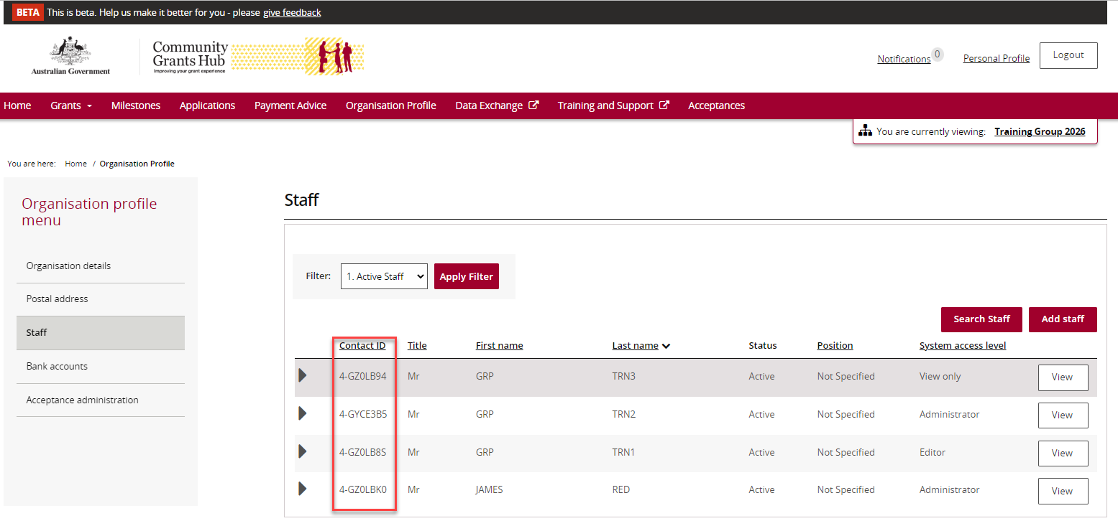
Find the staff member and select View.
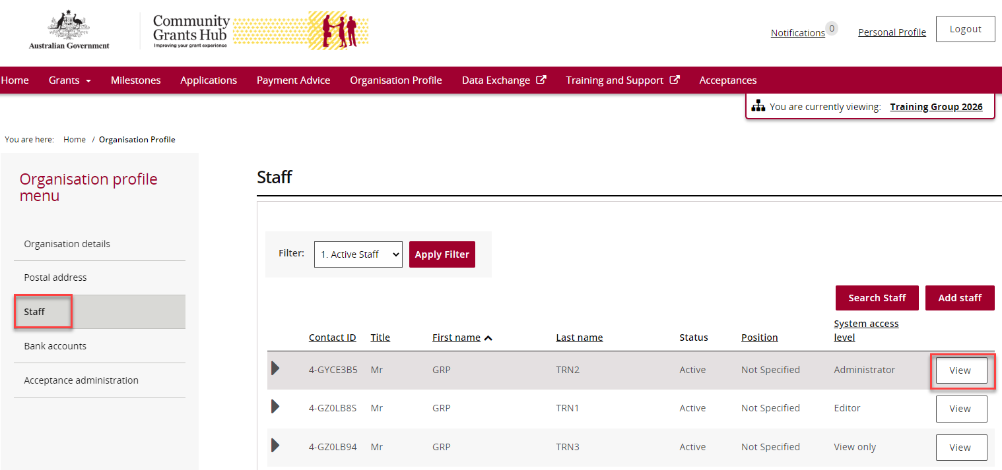
The Staff Details page contains four sections:
- Staff Details
- System Access
- Contact for Grant Agreements
- Contact for Grant Activities
This is where staff records can be reactivated or inactivated.
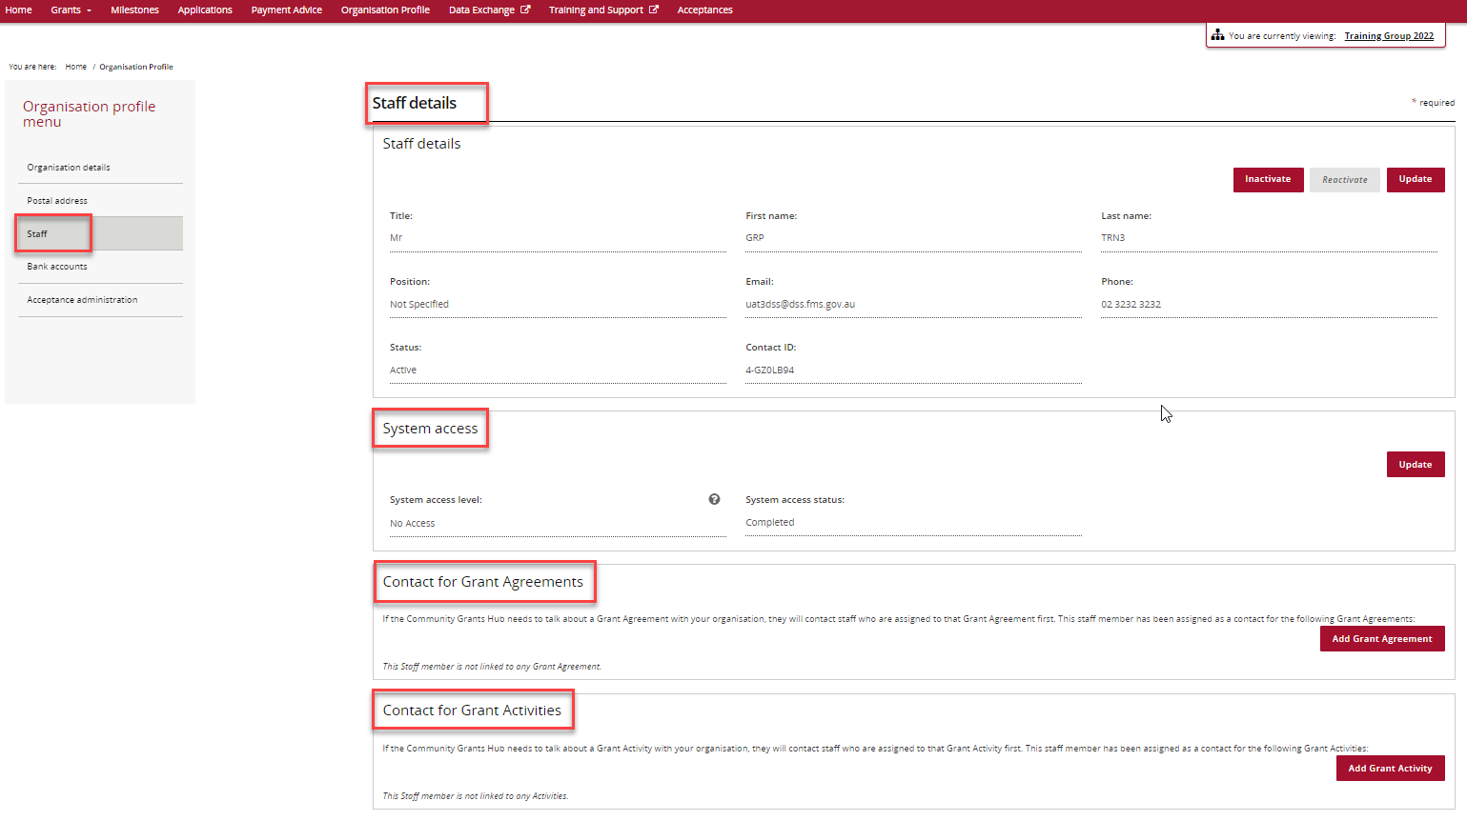
- If the staff member is Active, the Inactivate button is available.
- If the staff member is Inactive, the Reactivate button is available.
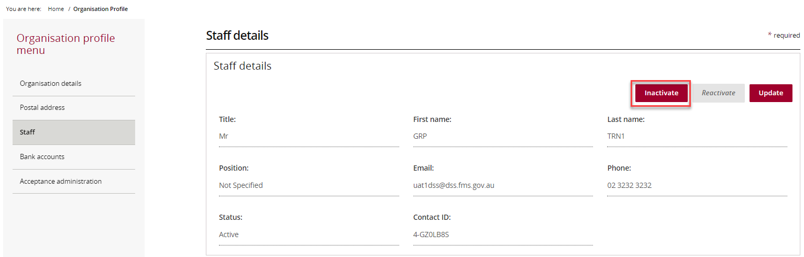
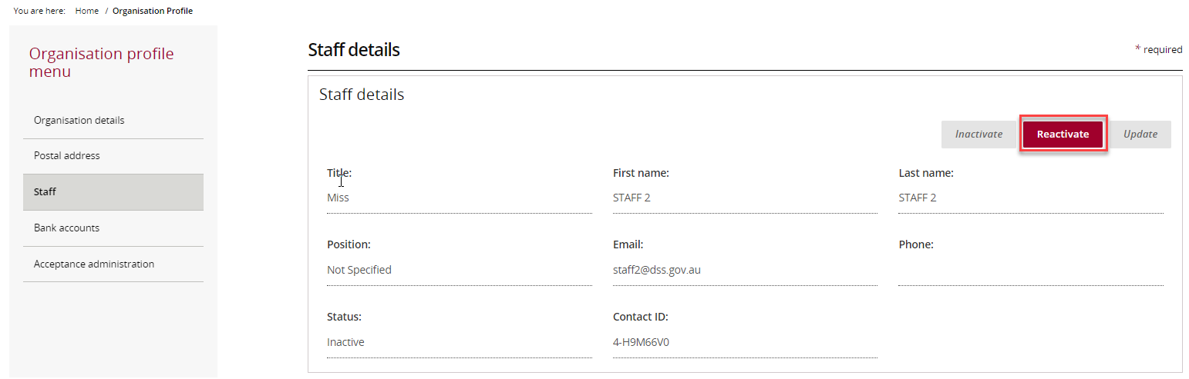

Reactivate a Staff Record
On the Staff screen:
- Select Inactive Staff from the filter.
- Select Apply Filter.
Note: The staff member must already exist as an inactive record.
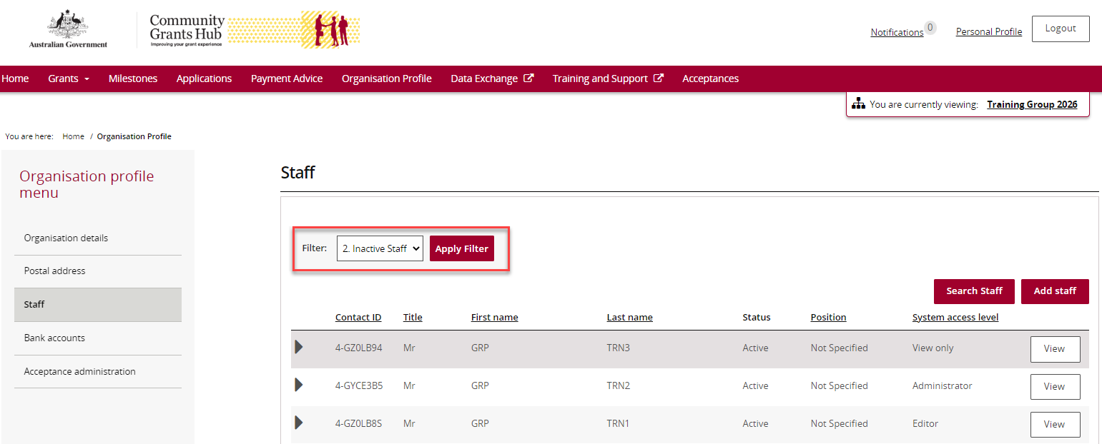
Select View beside the staff member you want to reactivate.
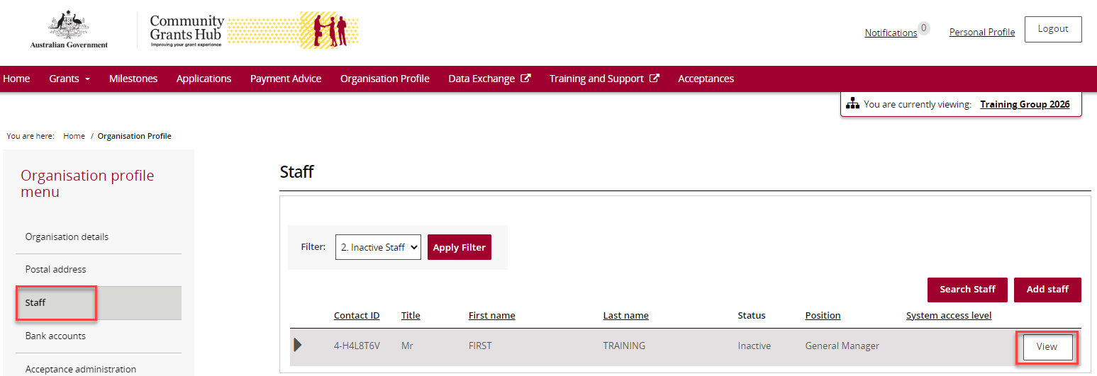
On the Staff Details page, select Reactivate.
Important:
- Reactivating a staff member does not automatically restore their previous Grant Agreement or Grant Activity contact roles.
- These relationships must be updated separately if required.
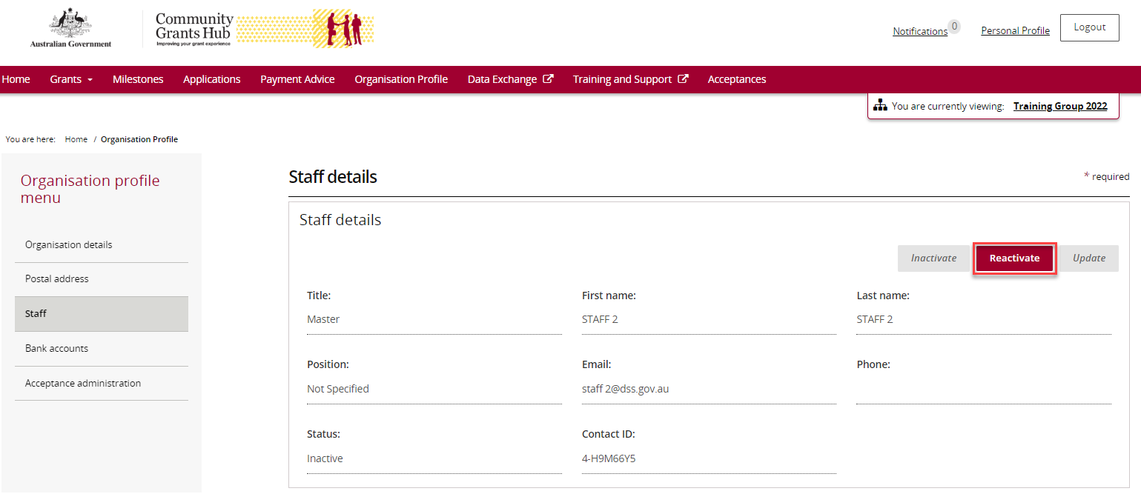
The staff member now appears in the Active Staff list.
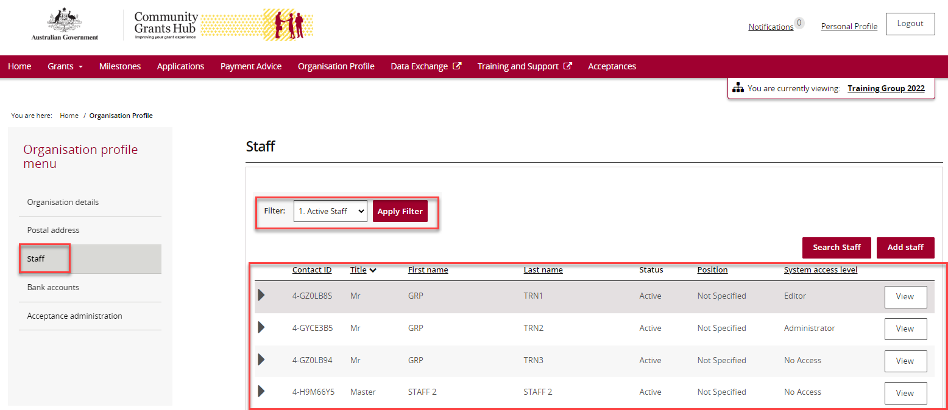

Inactivate a Staff Record
On the Staff screen:
- Select Active Staff from the filter.
- Select Apply Filter.
Note: The staff member must already exist as an active record.
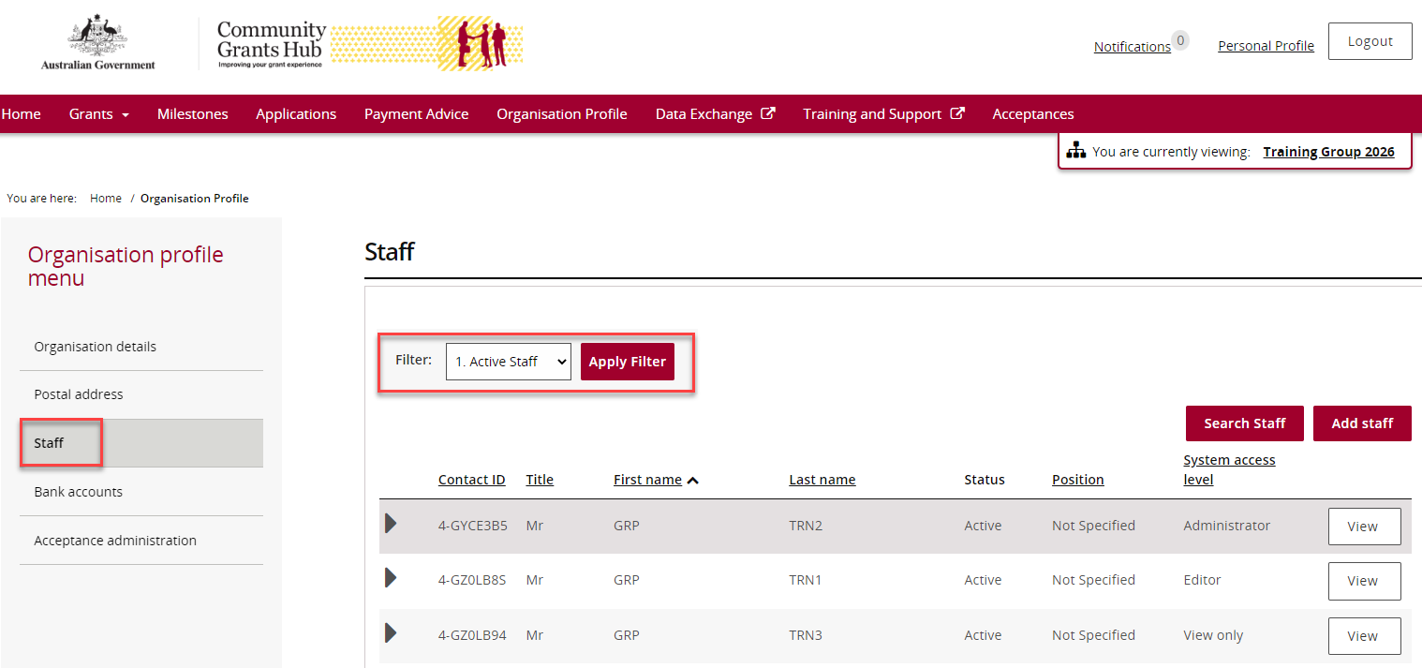
Select View beside the staff member you want to inactivate.
On the Staff Details page, select Inactivate.
You cannot inactivate a staff member if:
- They are the Primary Contact for a current Agreement, Program Schedule, or Activity.
In this situation, a new Primary Contact must be assigned first.
- They have a system access status of Requested.
In this situation, contact the Portal Helpdesk.
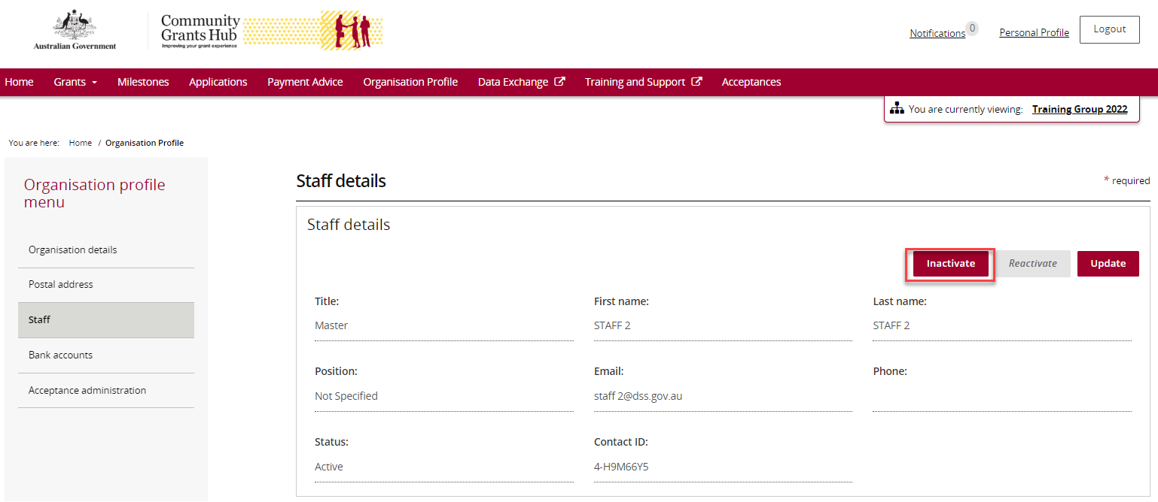
The staff member now appears in the Inactive Staff list.
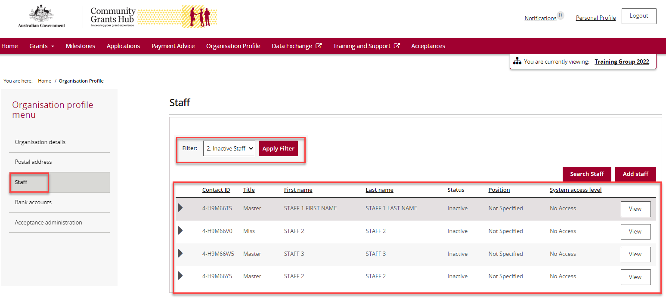

Need help?
For further assistance with the Grant Recipient Portal, please contact the Community Grants Hub at GRP.Helpdesk@communitygrants.gov.au.

