

Search for Organisation Staff
  - Task Card
The Grant Recipient Portal (Portal) allows users to view staff records and search for staff members linked to their organisation. This task card explains how to access staff records and use the staff search function.
Portal access required: Administrator, Editor or View Only.

Quick Links
View a Staff Record
Search for Organisation Staff
Need help?

View a Staff Record
From the Portal home page, select the Organisation Profile tile, or link from the navigation menu.
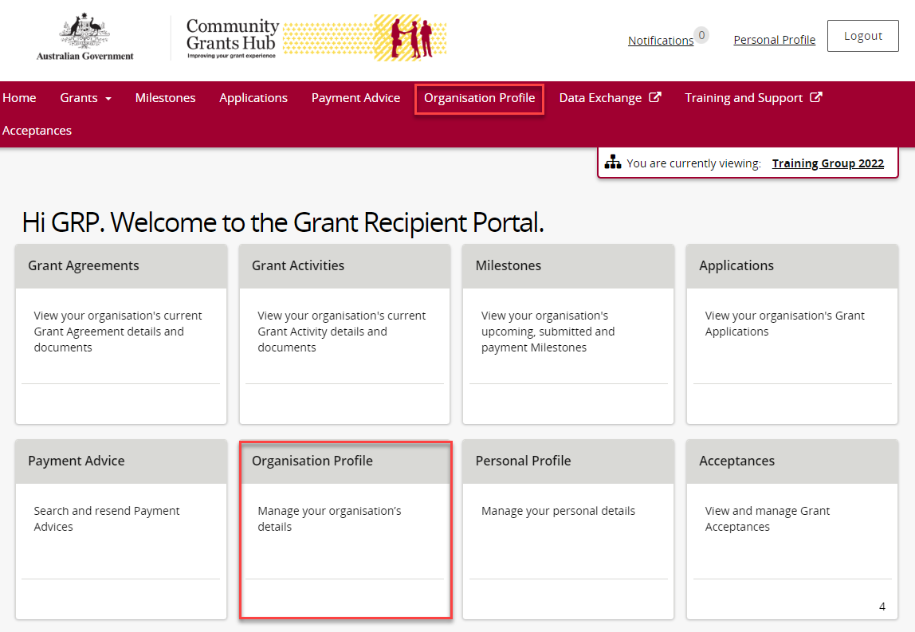
On the Organisation Profile page, select Staff from the menu on the left. The Staff page will open
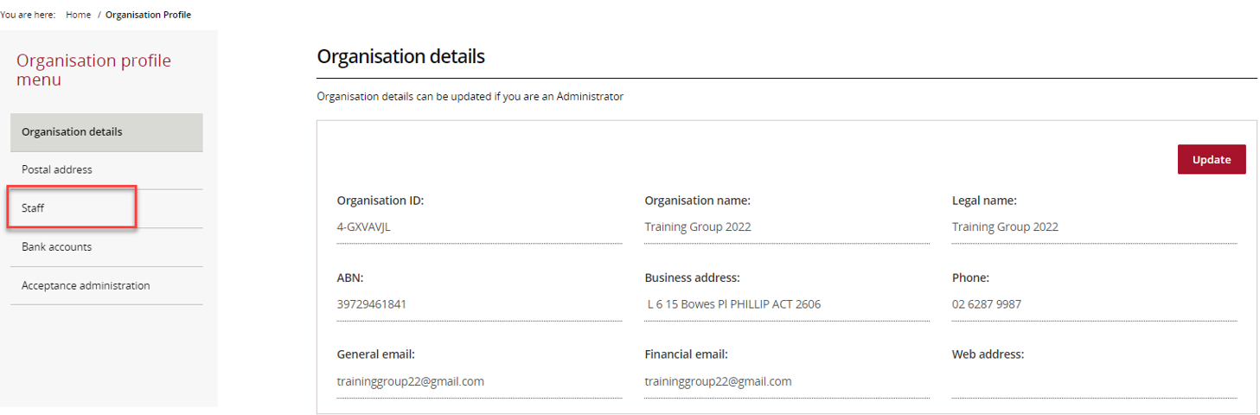
The Staff page displays a list of staff linked to your organisation. Active staff are shown by default.
The Status column shows whether a staff member is active or inactive.
Use the filter to choose:
- Active Staff
- Inactive Staff
- All Staff
Active staff are current organisation contacts in the Community Grant Hub’s Grant Payment System with no end date.
Inactive staff are former organisation contacts who have an end date recorded in the Community Grant Hub’s Grant Payment System.
The Portal will not show the end date.
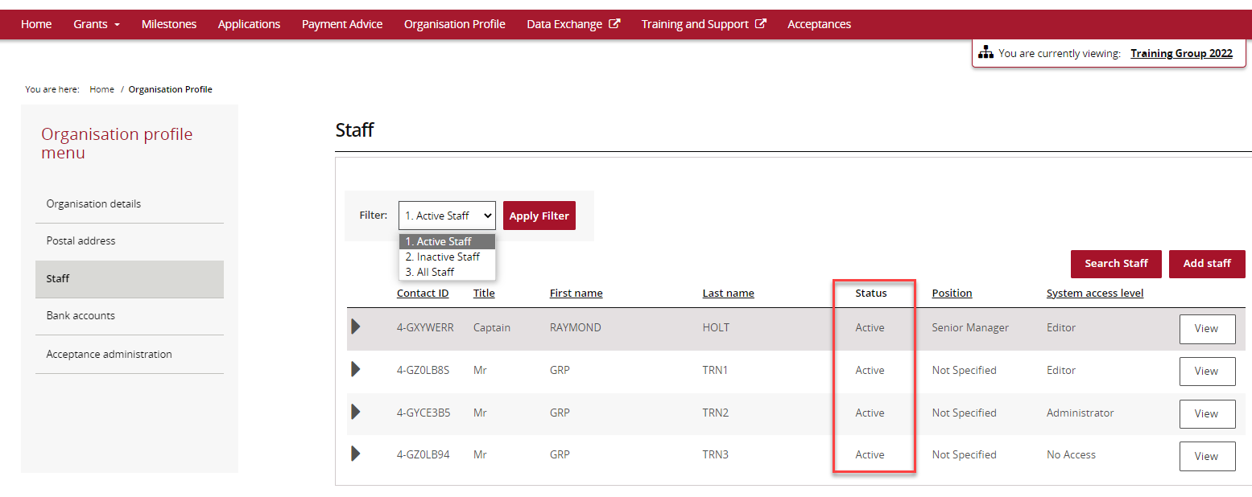
Each staff record includes a unique Contact ID that can be used to identify contacts and help manage duplicate records.
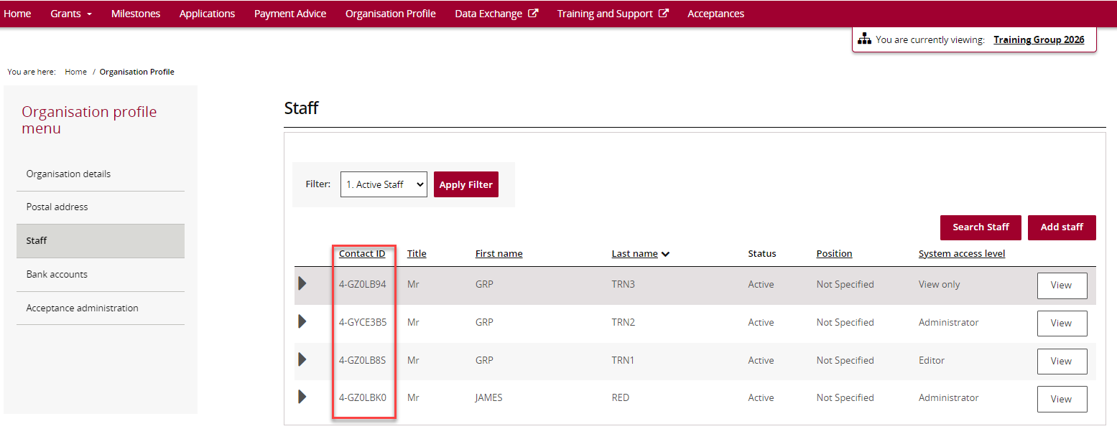
To view more information about a staff member, select View next to their name.
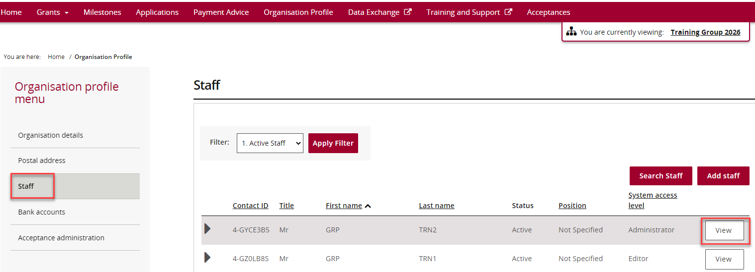
The Staff Details page displays information about the staff member.
The page includes:
- Staff Details
- System Access
- Contact for Grant Agreements
- Contact for Grant Activities
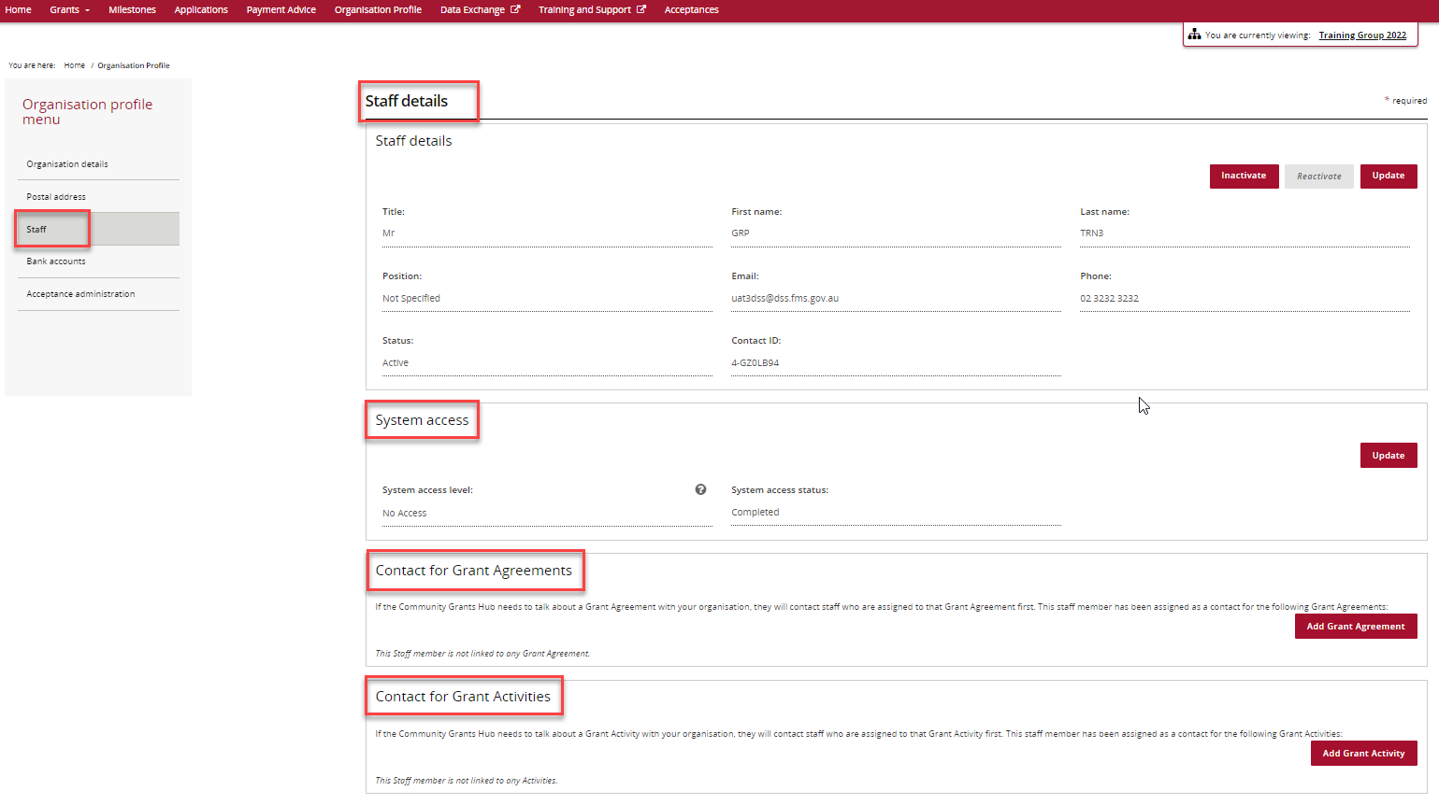

Search for Organisation Staff
From the Staff page, select Search Staff.
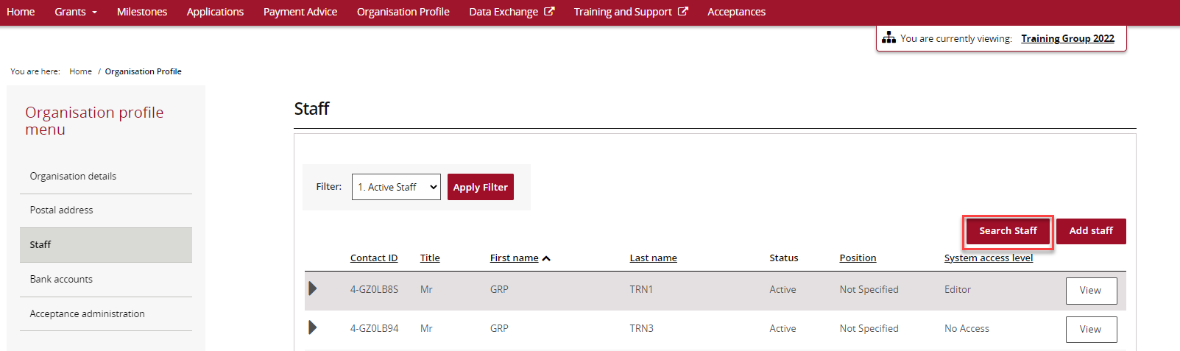
The Search Staff page allows you to search for staff members using one or more of the following fields:
- First Name
- Last Name
- Email
- Position
- Contact ID
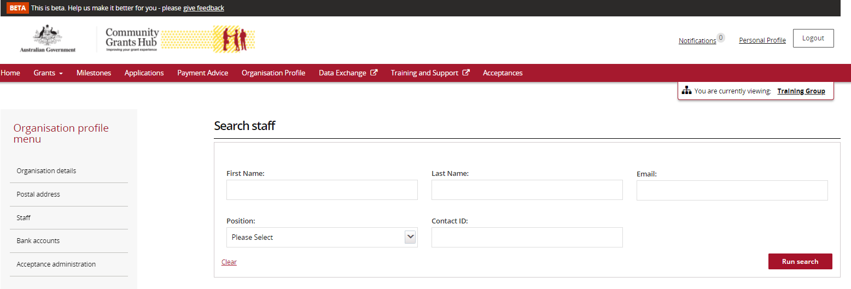
Enter the search details and select Run Search.
If you want to clear the search fields and start again, select Clear.
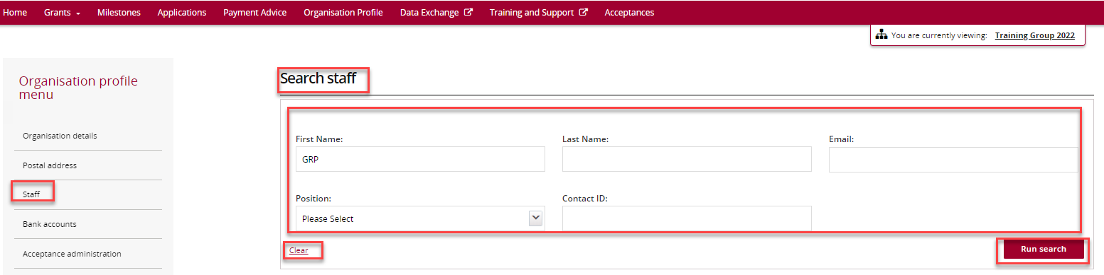
Search results will be displayed below the search fields.
To open a staff record, select View next to the staff member's name.
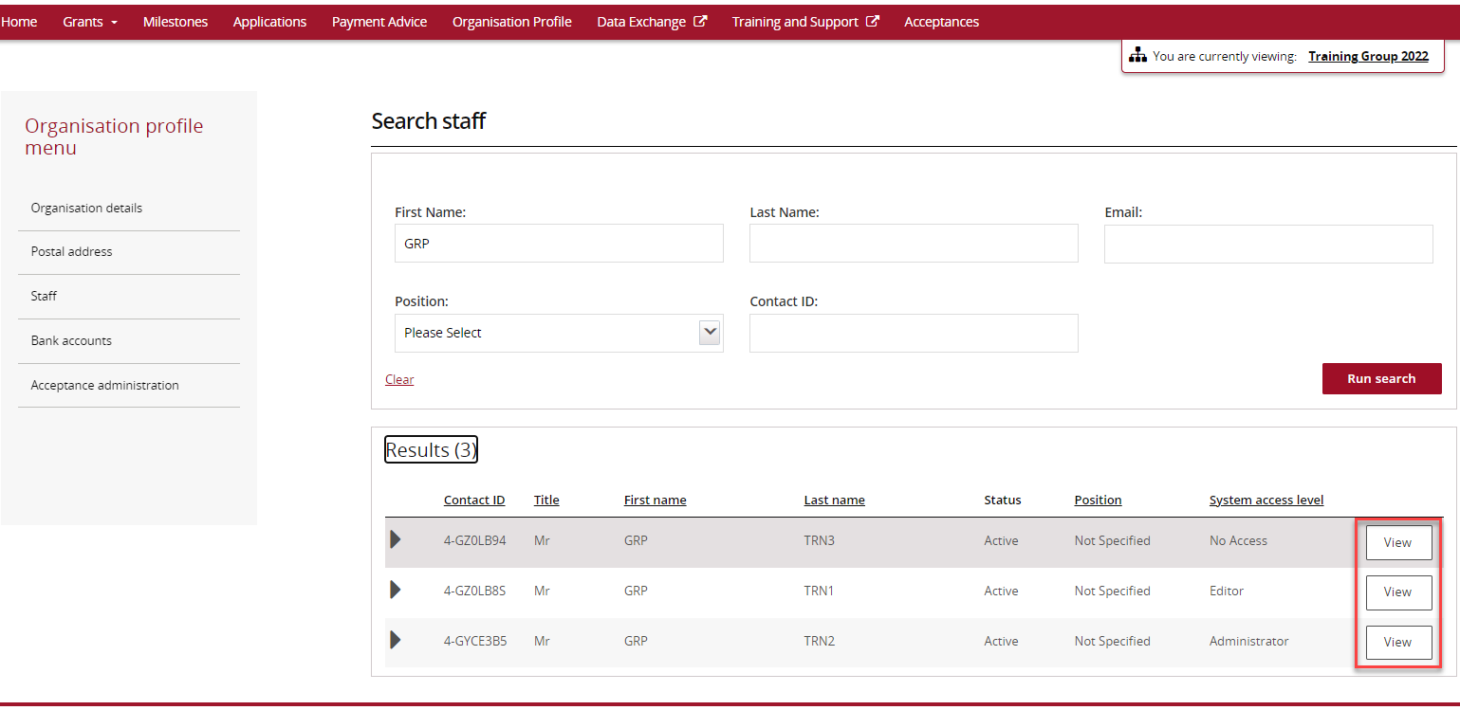

Need help?
For further assistance with the Grant Recipient Portal, please contact the Community Grants Hub at GRP.Helpdesk@communitygrants.gov.au.

