

Update Grant Activity Contacts
  - Task Card
This task card explains how to view, add, and remove Grant Activity Contacts in the Grant Recipient Portal (Portal).
You can manage Grant Activity Contacts in two ways:
- Through the Organisation Profile
- Through the Grant Activities section
Portal access required: Administrator or Editor.

Quick Links
Manage Contacts through Organisation Profile
Add a Contact through Organisation Profile
Remove a Contact through Organisation Profile
Manage Contacts through Grant Activities
Add a Contact through Grant Activities
Remove a Contact through Grant Activities
Need help?

Manage Contacts through Organisation Profile
From the Portal home page, select the Organisation Profile tile, or link from the navigation menu.
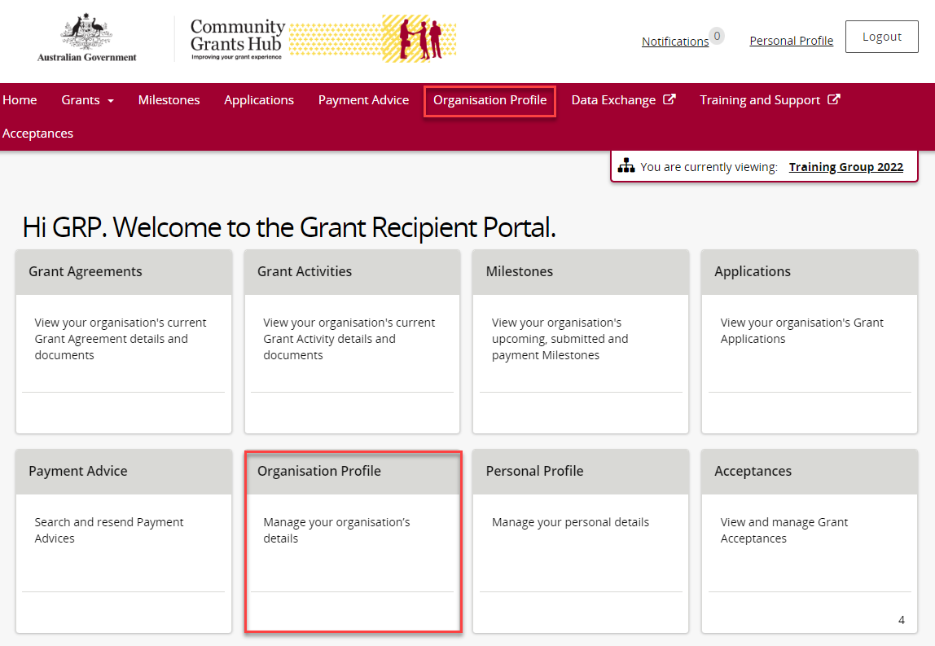
From the Organisation Profile menu, select Staff.
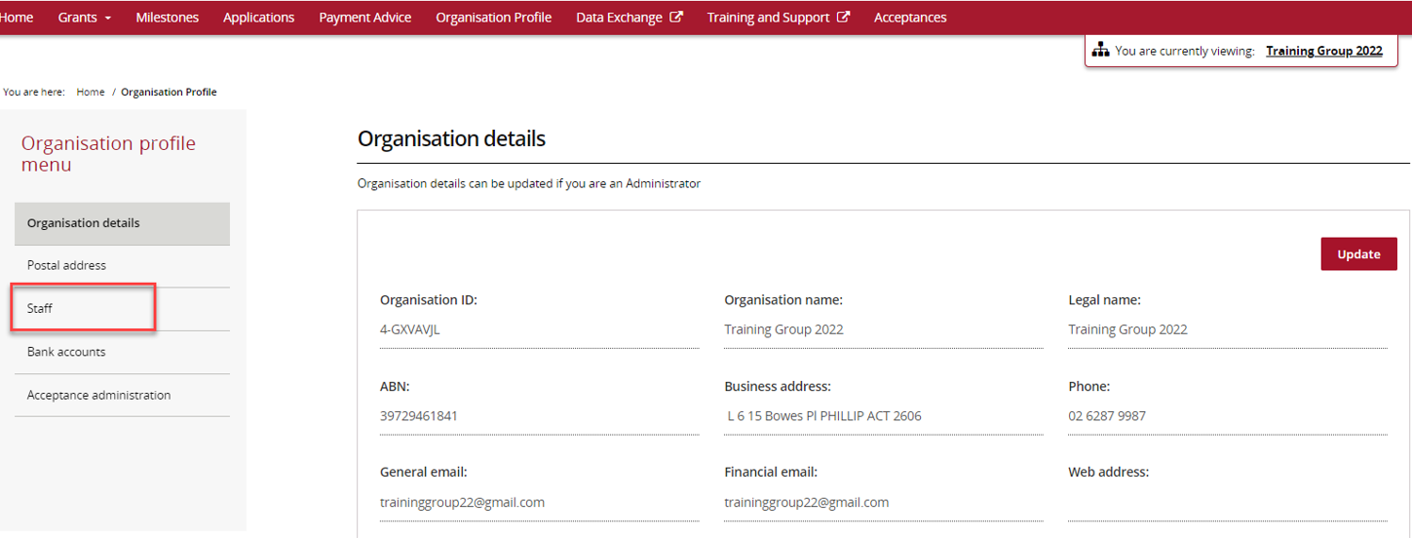
The Staff screen will display.
You can:
- View active staff.
- View inactive staff.
- View all staff.
Select View next to the staff member you want to manage.
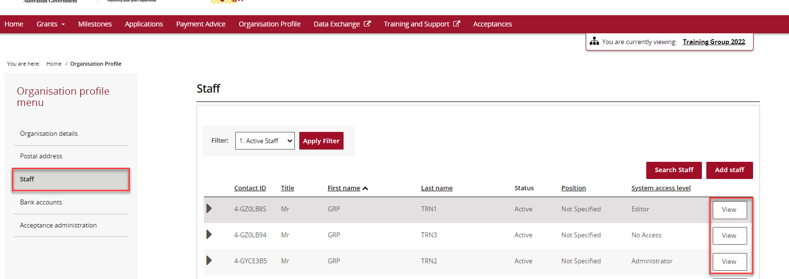
The Staff Details screen opens.
The screen contains:
- Staff Details
- System Access
- Contact for Grant Agreements
- Contact for Grant Activities
Grant Activity Contacts are listed under Contact for Grant Activities.
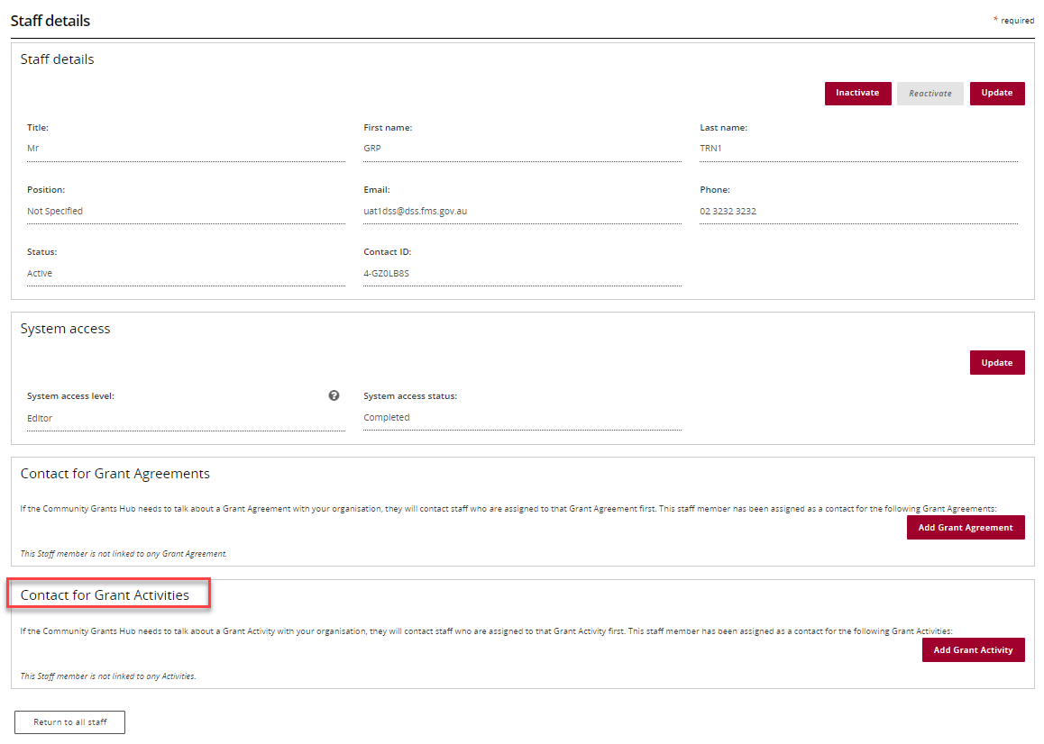
- To add a contact, continue to the next section.
- To remove a contact, skip to Remove a Contact through Organisation Profile task card section.

Add a Contact through Organisation Profile
Go to Staff and select View beside the staff member you want to add as a contact.
On the Staff Details page, select Add Grant Activity.
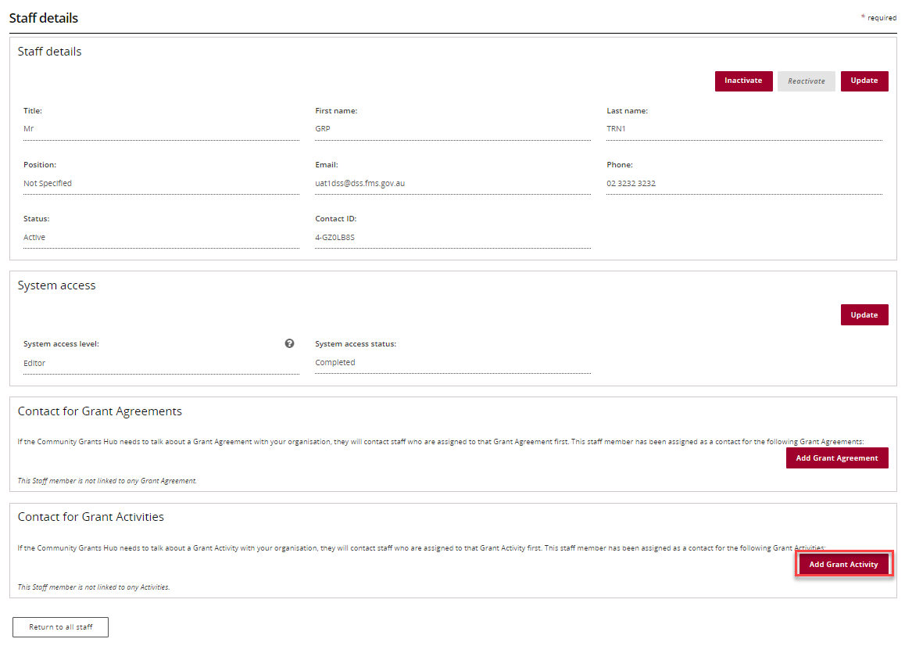
A list of available Grant Activities will appear.
Select Actions beside the relevant activity.
Available options are:
- Assign as a contact
- Assign as the primary contact
- View all contacts for this activity
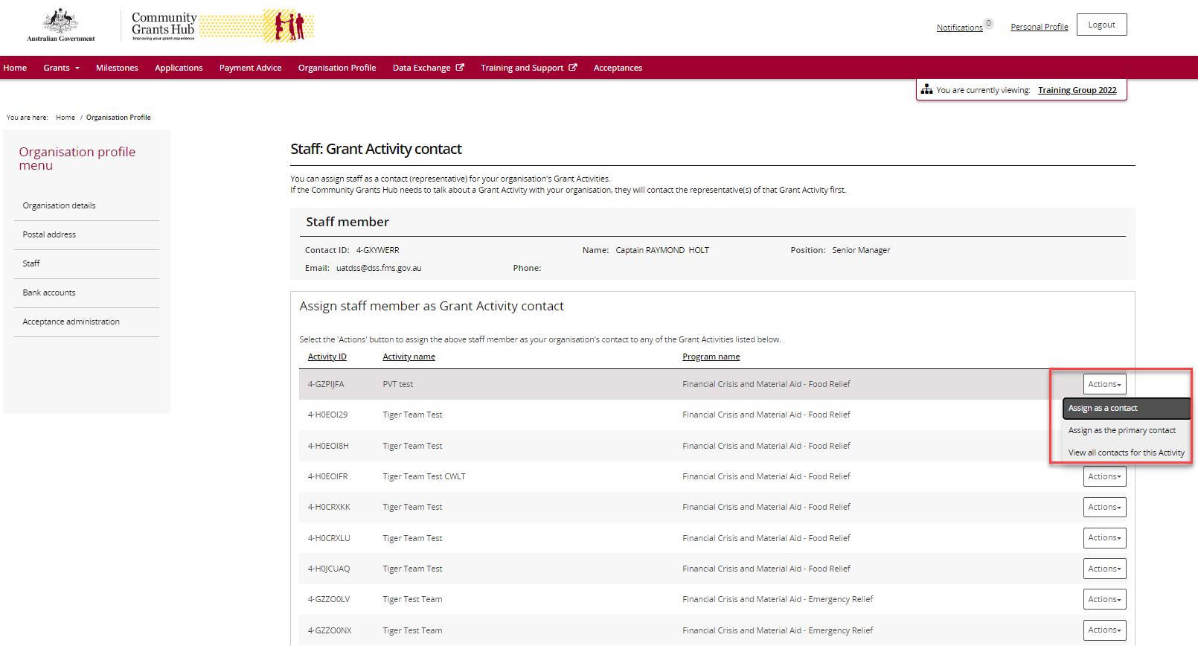
To add the person as a standard contact, select Assign as a contact.
A success message will appear.
The activity will show under Contact for Grant Activities with Primary Activity Contact as No.
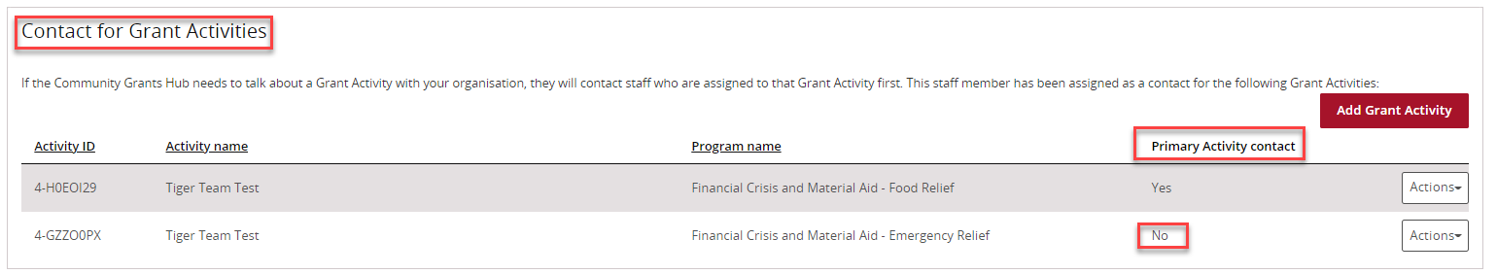
To add the person as the primary contact, select Assign as the primary contact.
A confirmation message will appear.
Select Confirm to proceed.
You can select Discard changes and return if you do not wish to continue.
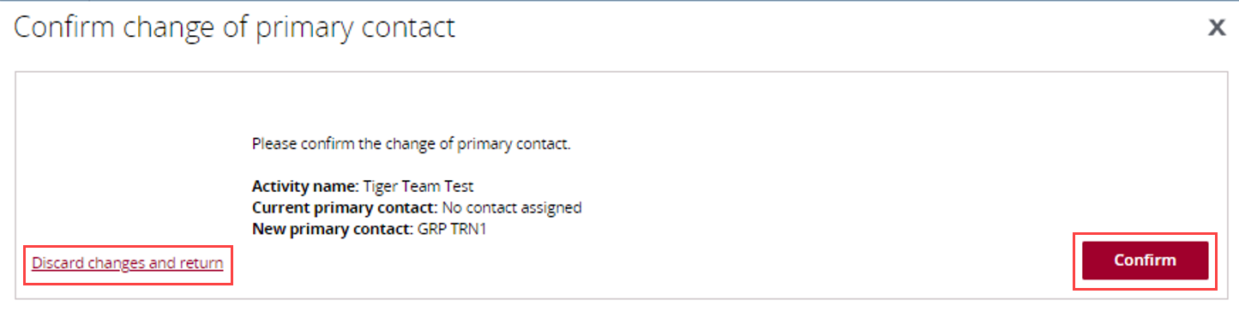
A success message will appear.
The activity will now show under Contact for Grant Activities with Primary Activity Contact as Yes.
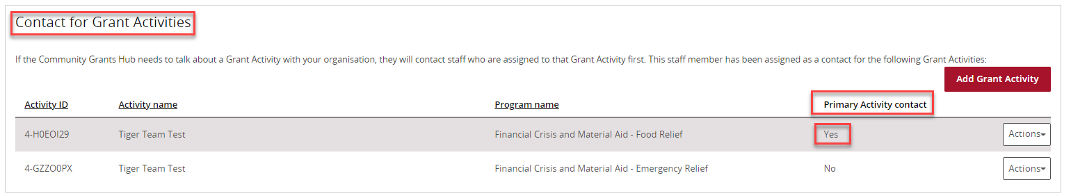

Remove a Contact through Organisation Profile
Go to Staff and select View beside the staff member you want to remove.
Go to the Contact for Grant Activities section.
Select Actions beside the activity and choose Remove contact from Activity.
Note: You cannot remove a person who is currently the primary contact. A new primary contact must be assigned first.
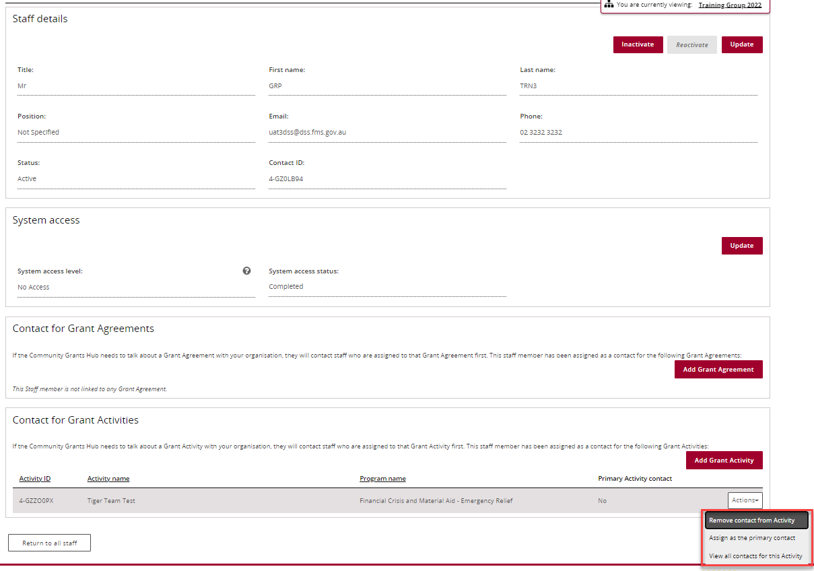
If successful, a confirmation message will appear, and the activity will no longer be listed for that staff member.
If the contact is the current primary contact, an error message will display advising that a new primary contact must be assigned before removal.
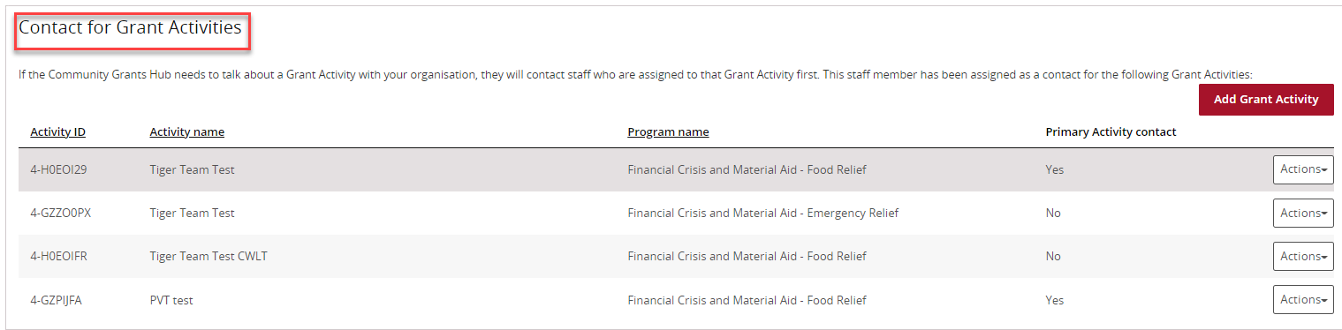

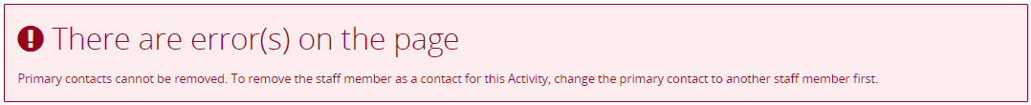

Manage Contacts through Grant Activities
From the Portal home page:
- Select the Grant Activities tile, or
- Select Grants from the menu and then select Grant Activities.
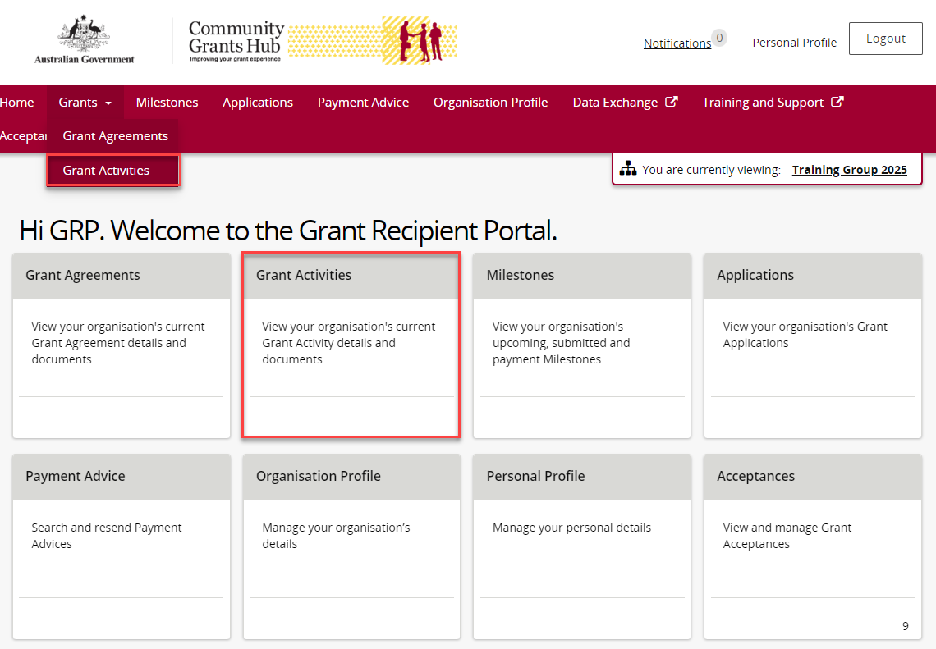
The Grant Activities screen will display.
Find the activity you want to manage and select View.
You can also use Search Activities.
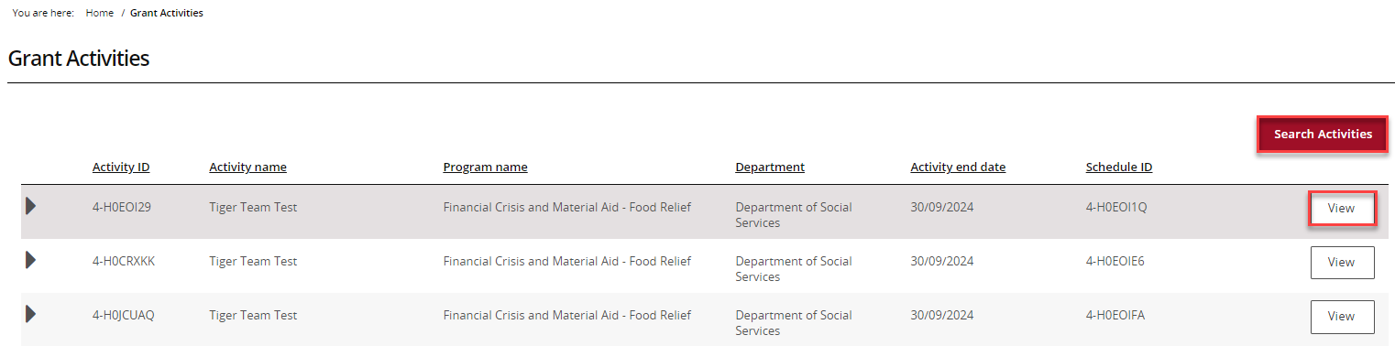
The Activity Details screen will open.
You can view information including:
- Activity name
- Activity ID
- Program name
- Organisation details
- Activity dates
- Funding Arrangement Manager
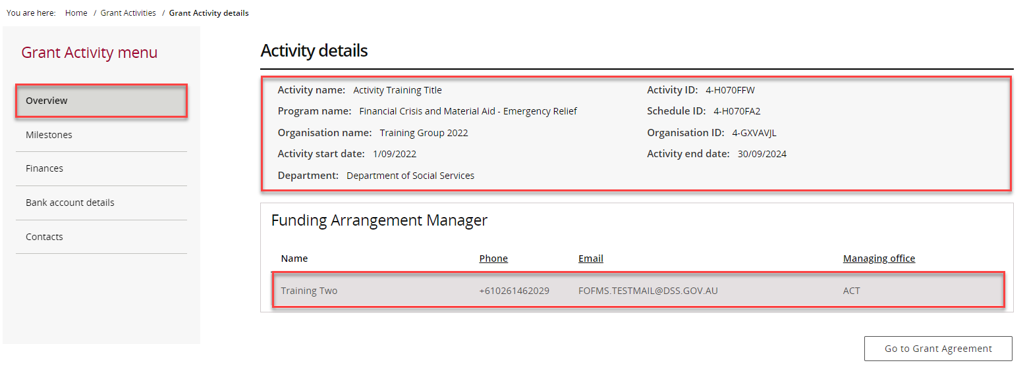
Select Contacts from the Grant Activity menu.
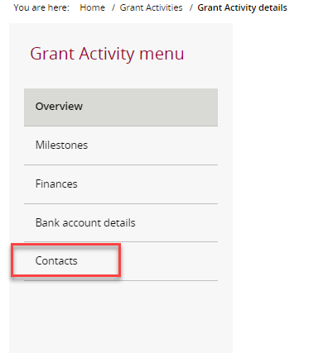
The Contacts screen will display all contacts linked to the activity.
- To add a contact, continue to the next section.
- To remove a contact, skip to Remove a Contact through Grant Activities task card section.
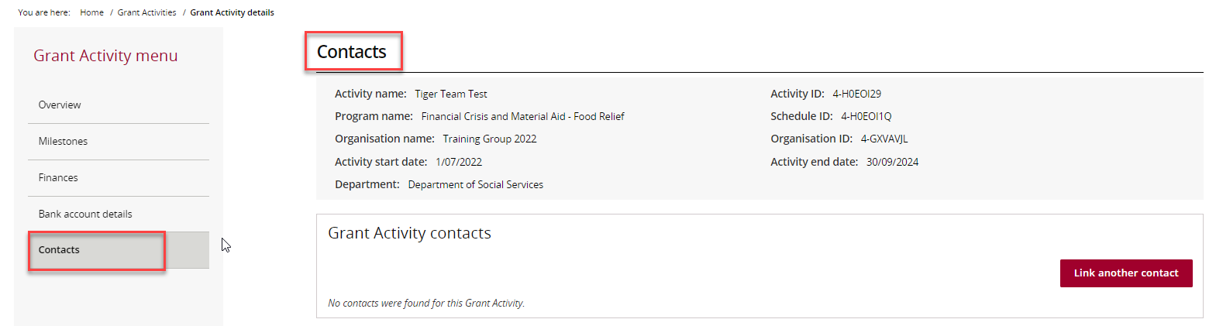

Add a Contact through Grant Activities
Select Link another contact.
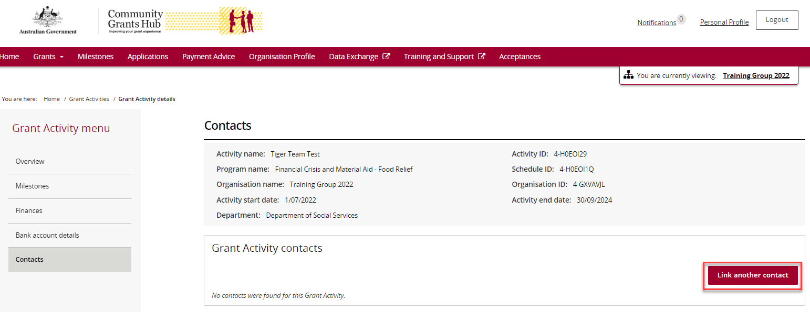
A list of staff members will appear.
Select the checkbox beside the person you want to add, then select Confirm selection.
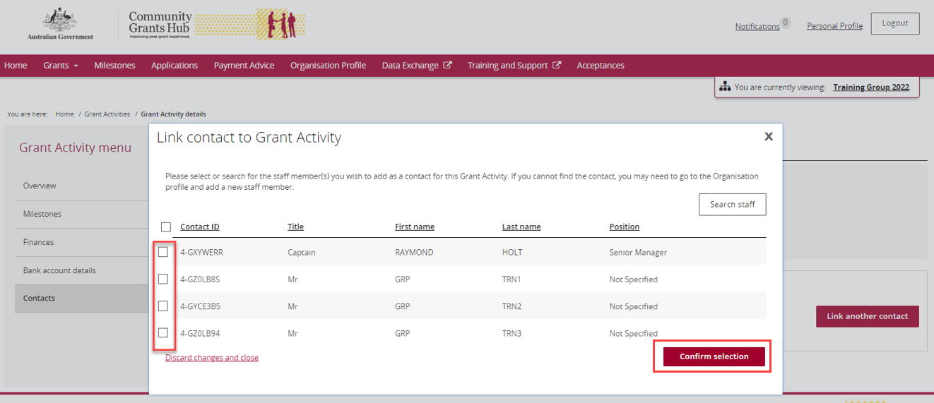
A success message will appear.
The person will now appear under Grant Activity Contacts.
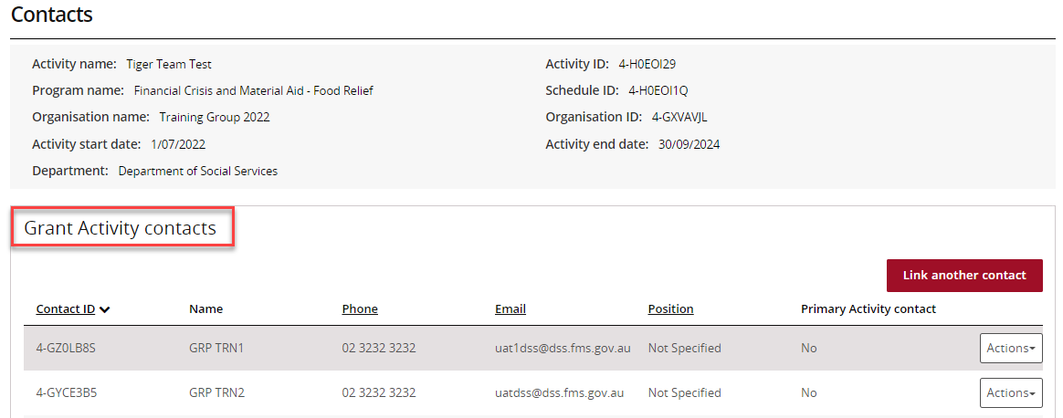
To make the contact the primary contact:
- Select Actions
- Select Assign as the primary contact
The current primary contact is identified by Yes in the Primary Activity Contact column.
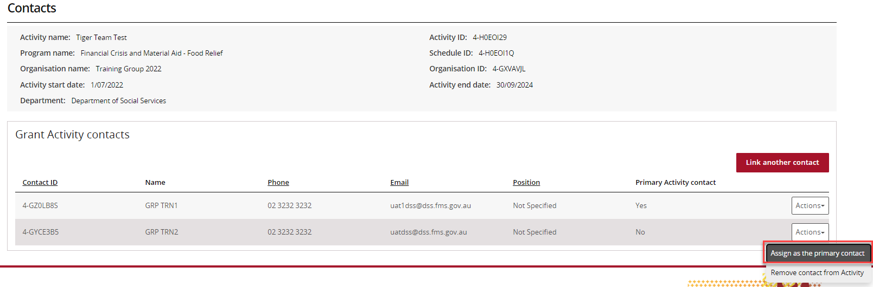
A confirmation window will appear.
Select Continue to make the change.
Select Discard changes and return if you do not want to proceed.
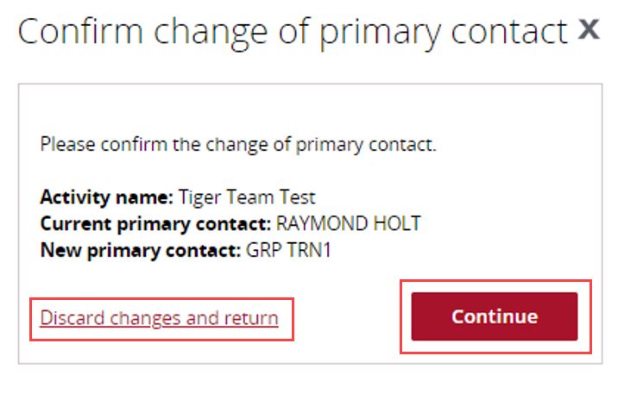
A success message will appear.
The contact will now display Yes under Primary Activity Contact.
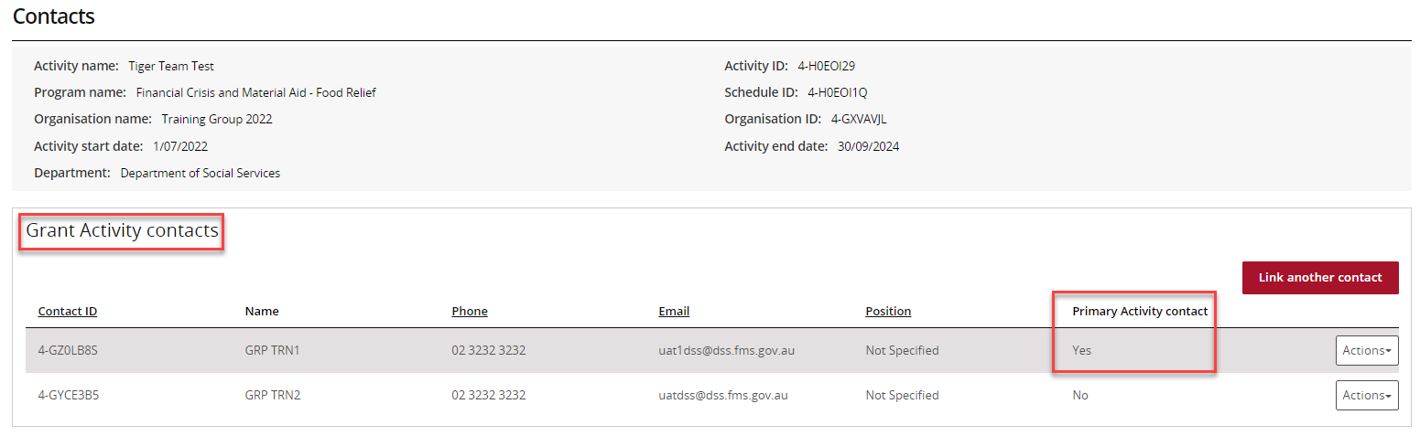

Remove a Contact through Grant Activities
From the Contacts screen:
- Select Actions beside the contact.
- Select Remove contact from Activity.
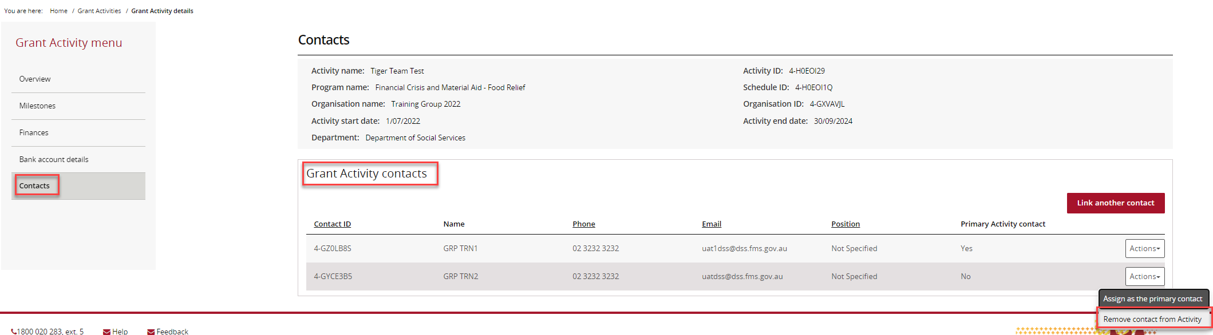
A confirmation window will appear.
Select Yes remove as contact.
Select Cancel if you do not wish to continue.
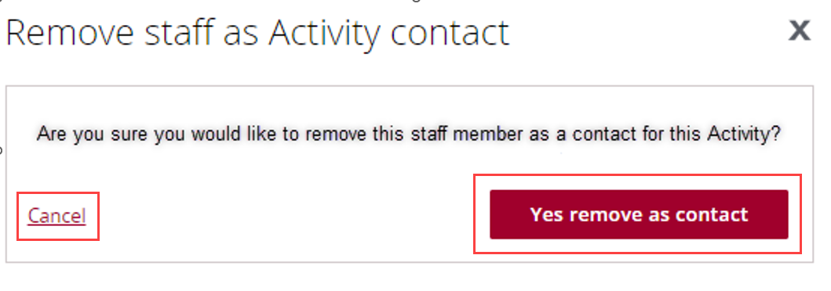
A success message will appear, and the contact will be removed from the activity.
If the contact is currently the primary contact, an error message will display advising that another primary contact must be assigned first.
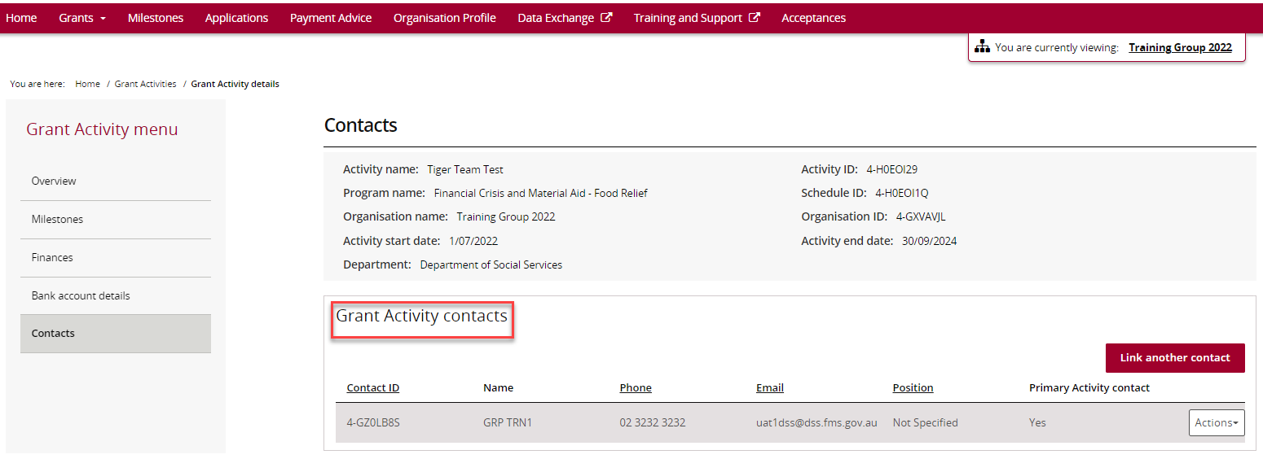

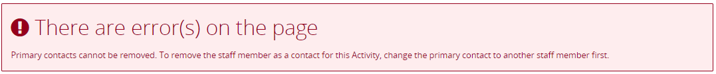

Need help?
For further assistance with the Grant Recipient Portal, please contact the Community Grants Hub at GRP.Helpdesk@communitygrants.gov.au.

