

Update Grant Agreement Contacts
  - Task Card
This task card explains how to view, add, and remove Grant Agreement Contacts in the Grant Recipient Portal (Portal).
You can manage Grant Agreement Contacts in two ways:
- Through the Organisation Profile, or
- Through the Grant Agreements section
Portal access required: Administrator or Editor.

Quick Links
Manage Contacts through Organisation Profile
Add a Contact through Organisation Profile
Remove a Contact through Organisation Profile
Manage Contacts through Grant Agreements
Add a Contact through Grant Agreements
Remove a Contact through Grant Agreements
Need help?

Manage Contacts through Organisation Profile
From the Portal home page, select the Organisation Profile tile, or link from the navigation menu.
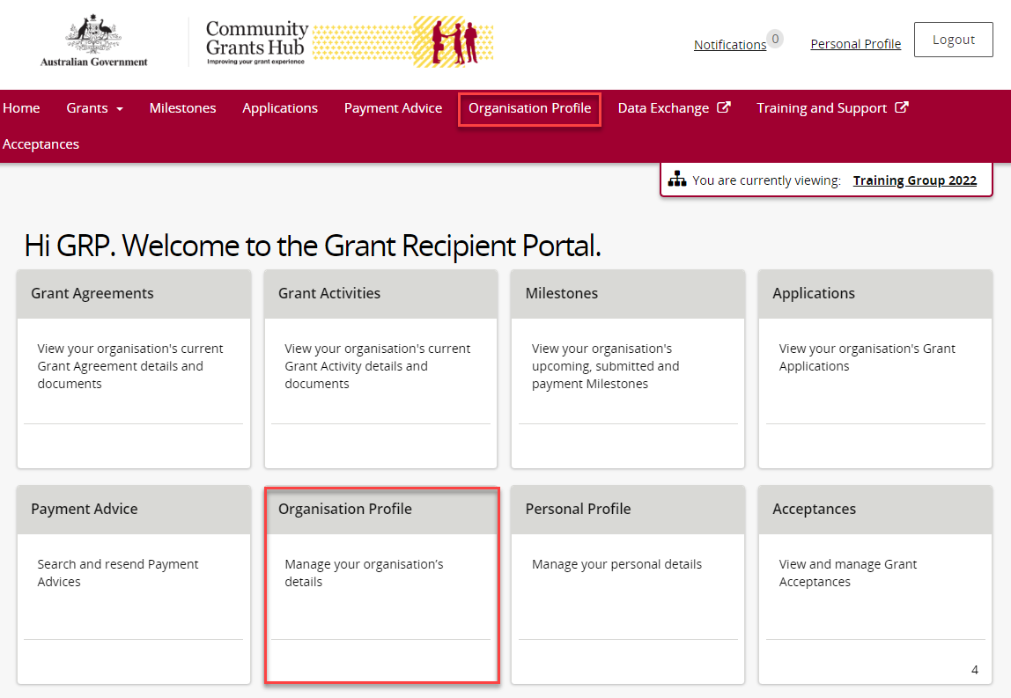
From the Organisation Profile menu, select Staff.
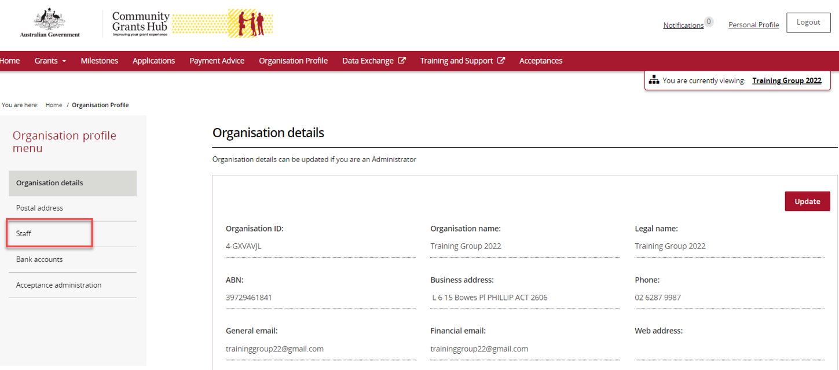
The Staff screen will display.
You can:
- View active staff
- View inactive staff
- View all staff
Select View next to the staff member whose Grant Agreement contacts you want to manage.
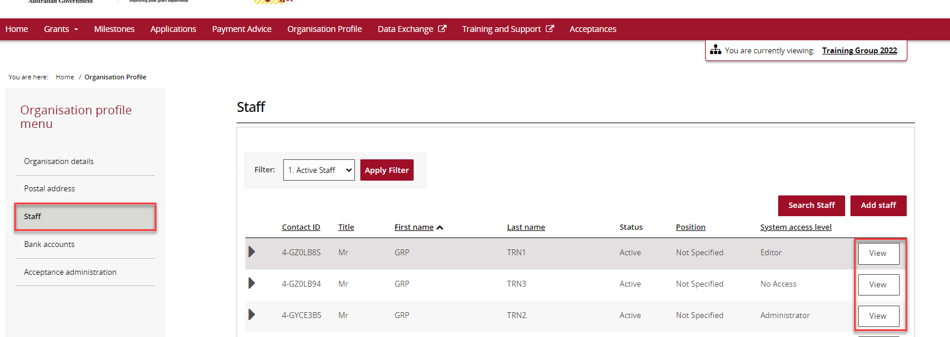
The Staff Details screen opens.
This screen contains:
- Staff Details
- System Access
- Contact for Grant Agreements
- Contact for Grant Activities
Grant Agreement Contacts are listed under Contact for Grant Agreements.
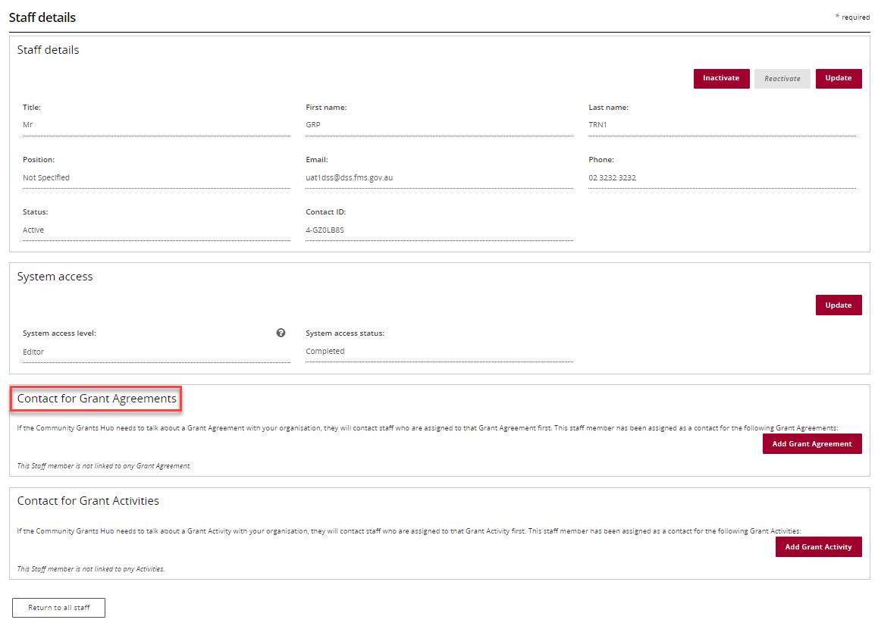

Add a Contact through Organisation Profile
Go to Staff and select View beside the staff member you want to add as a contact.
On the Staff Details screen, select Add Grant Agreement.
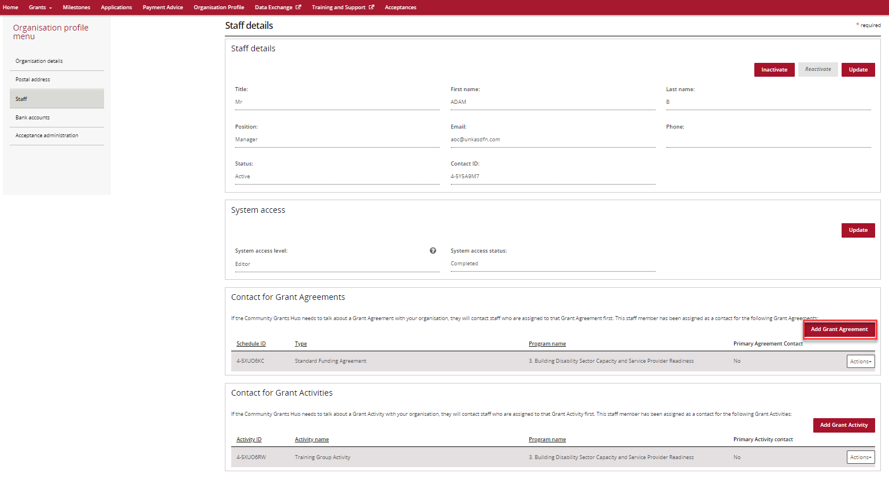
A list of Grant Agreements will appear.
Select Actions beside the relevant agreement.
Available options are:
- Assign as a contact.
- Assign as the primary contact.
- View all contacts for the agreement.
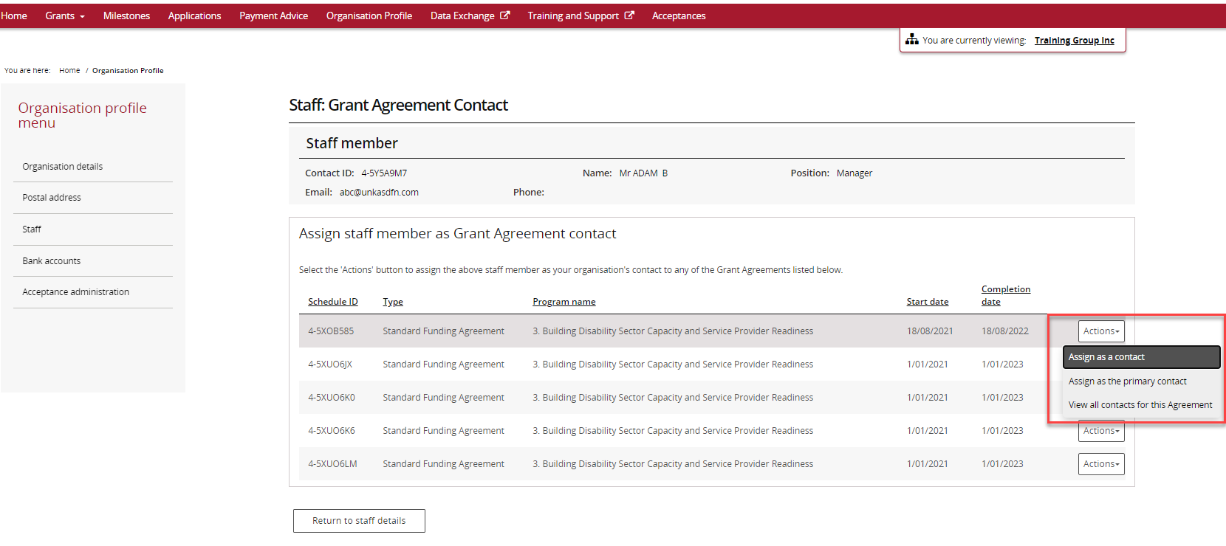
To add the person as a standard contact, select Assign as a contact.
A success message will appear.
The agreement will show under Contact for Grant Agreements with Primary Agreement Contact as No.
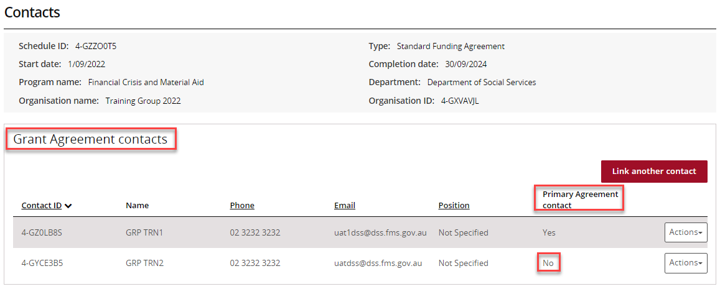
To add the person as the primary contact, select Assign as the primary contact.
A confirmation message will appear.
Select Continue to proceed.
You can select Discard changes and return if you do not wish to continue.
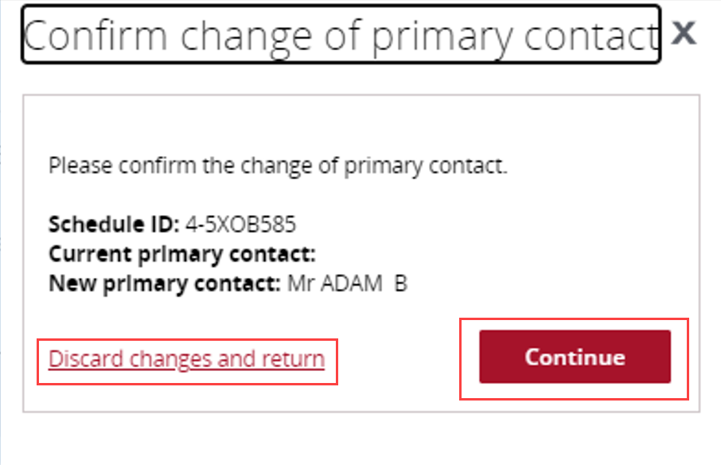
A success message will appear.
The contact will now show under Contact for Grant Agreements with Primary Agreement Contact as Yes.
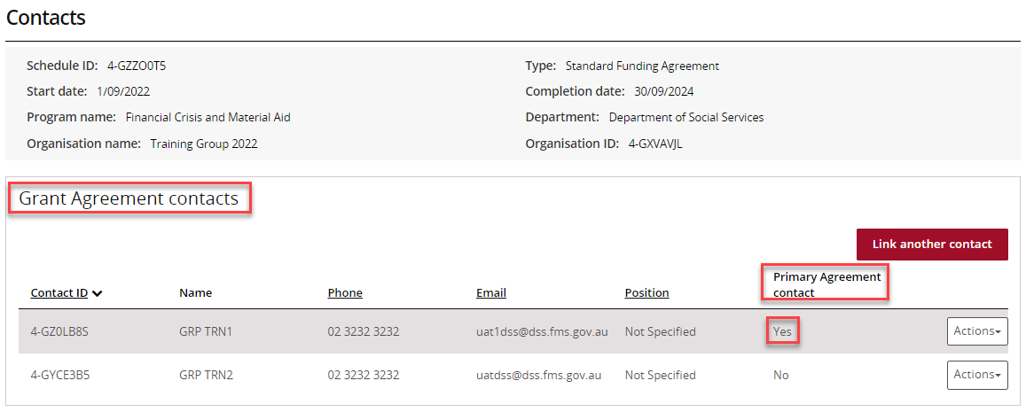

Remove a Contact through Organisation Profile
Go to Staff and select View beside the staff member you want to remove.
Go to the Contact for Grant Agreements section.
Select Actions beside the agreement and choose Remove contact from Agreement.
Note: You cannot remove a person who is currently the primary contact. A new primary contact must be assigned first.
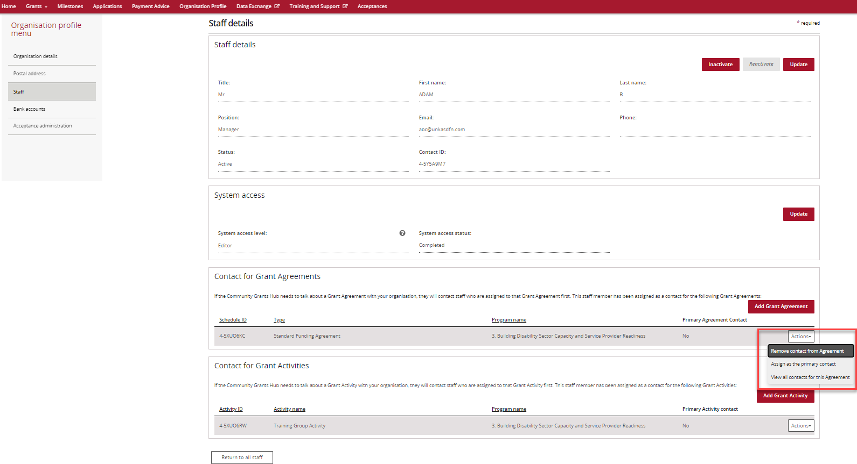
If successful, a confirmation message will appear, and the agreement will no longer be listed for that staff member.
If the contact is the current primary contact, an error message will display advising that a new primary contact must be assigned before removal.

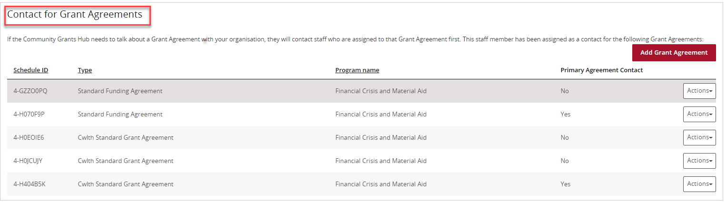
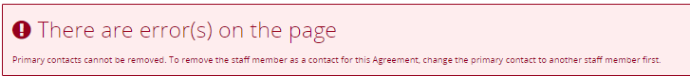

Manage Contacts through Grant Agreements
From the Portal home page:
- Select the Grant Agreements tile, or
- Select Grants from the menu and then select Grant Agreements.
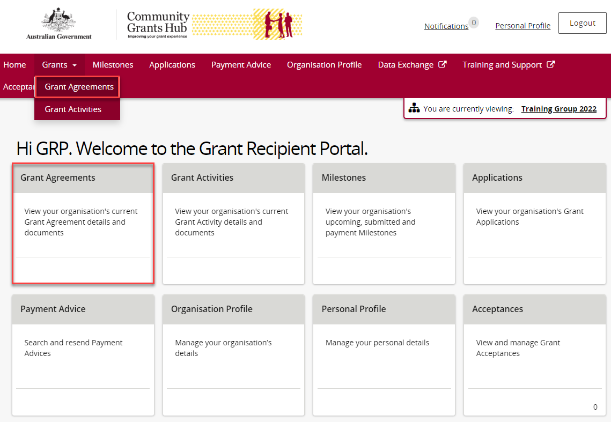
The Grant Agreements screen will display.
Find the agreement you want to manage and select View.
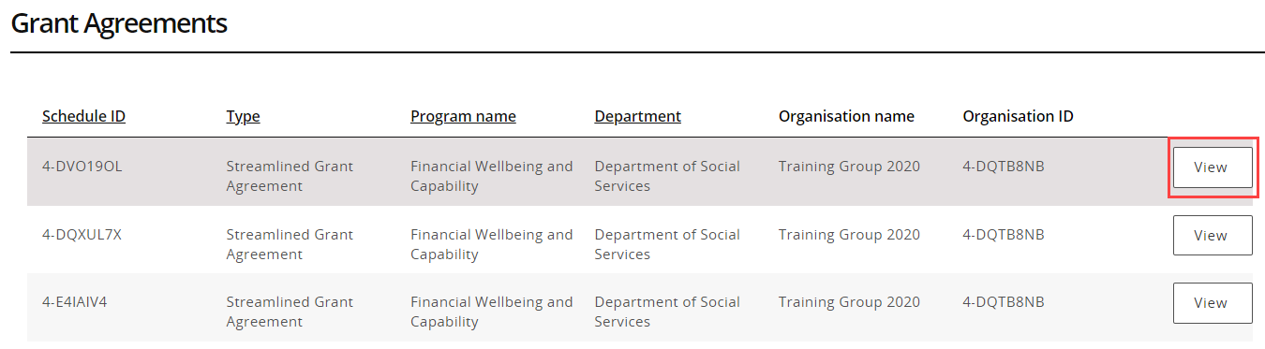
The Agreement Details screen will open.
You can view information including:
- Schedule ID
- Agreement type
- Start date
- Completion date
- Program name
- Department
- Organisation name
- Organisation ID
You can also see any linked Grant Activities.
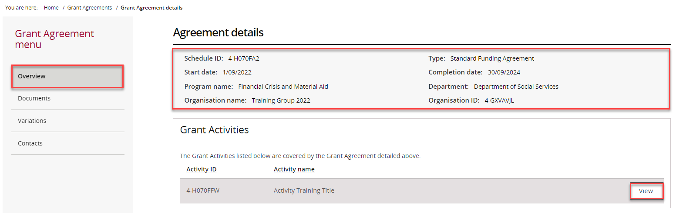
Select Contacts from the Grant Agreement menu.
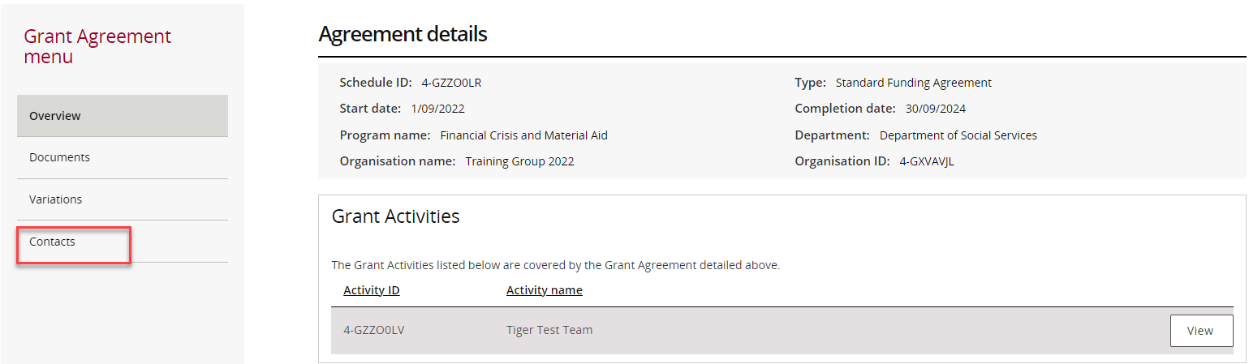
The Contacts screen will display all contacts linked to the agreement.
- To add a contact, continue to the next section.
- To remove a contact, skip to Remove a Contact through Grant Agreements task card section.
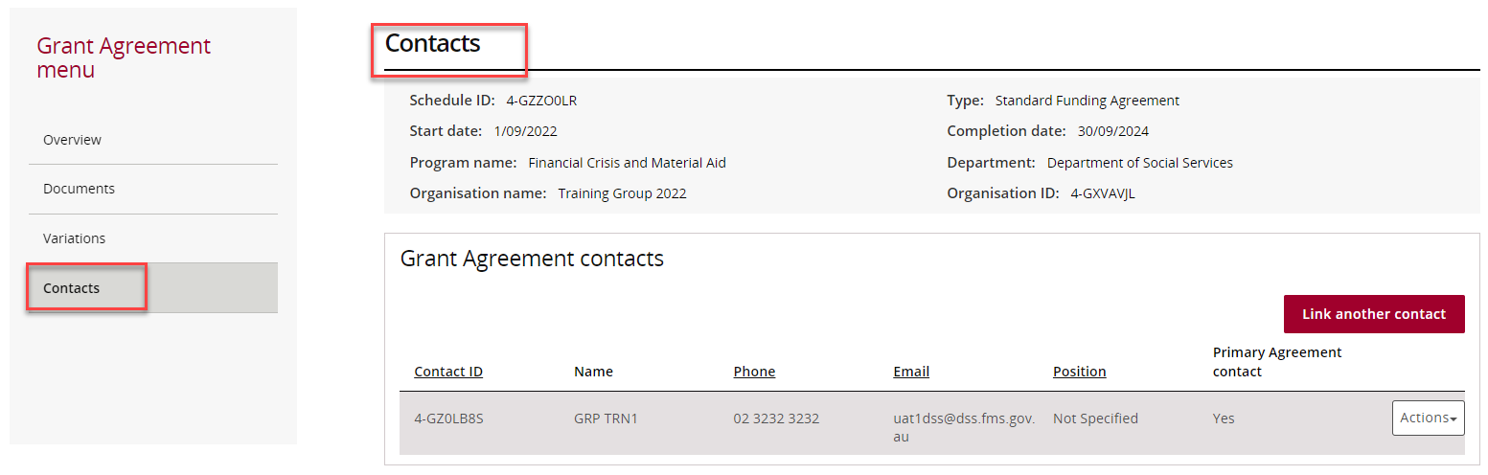

Add a Contact through Grant Agreements
Select Link another contact.
A list of staff members will appear.
Select the checkbox beside the person you want to add, then select Confirm selection.
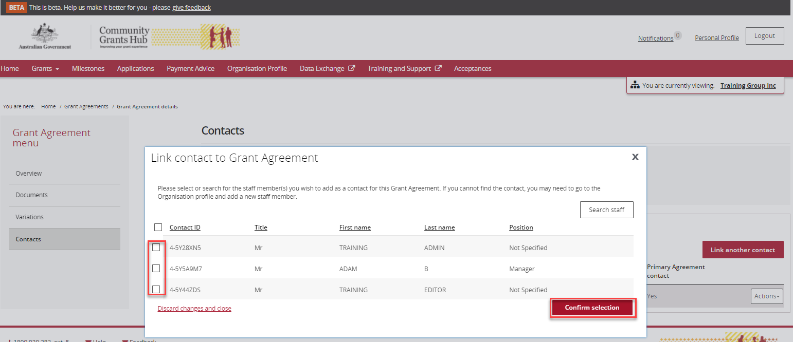
A success message will appear.
The person will now appear under Grant Agreement Contacts.
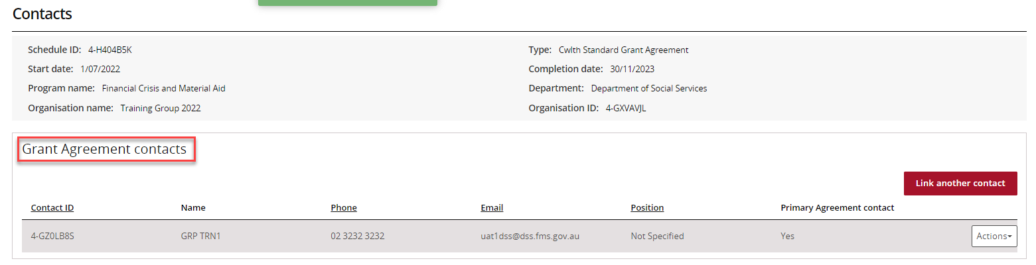
To make the contact the primary contact:
- Select Actions
- Select Assign as the primary contact
The current primary contact is identified by Yes in the Primary Agreement Contact column.
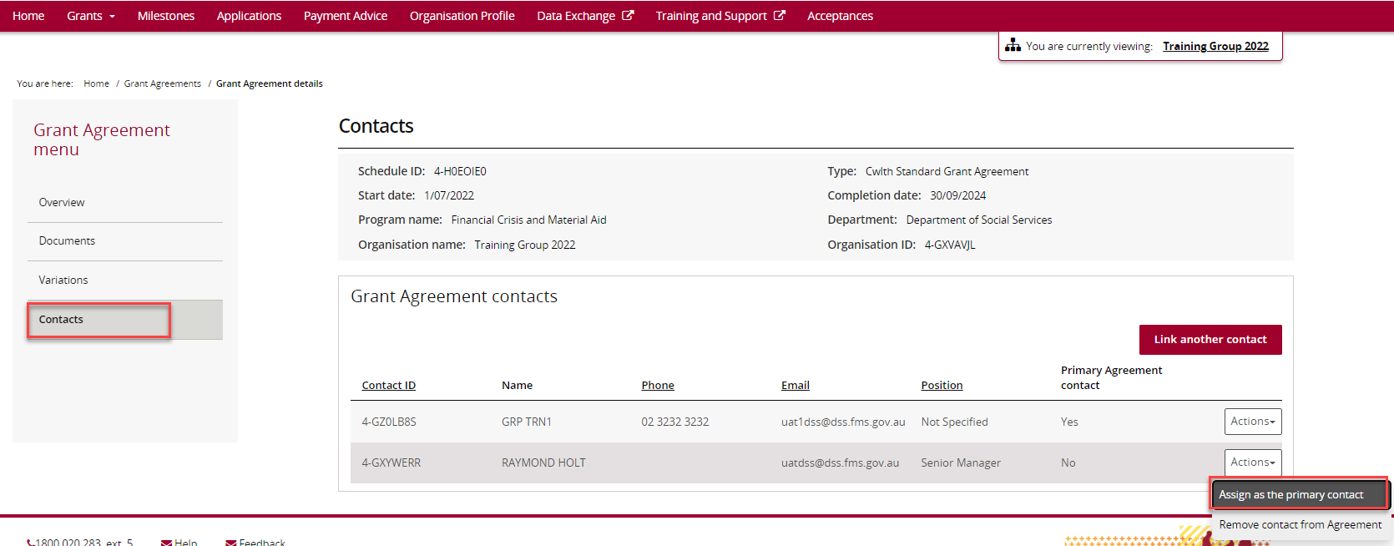
A confirmation window will appear.
Select Continue to make the change.
Select Discard changes and return if you do not want to proceed.
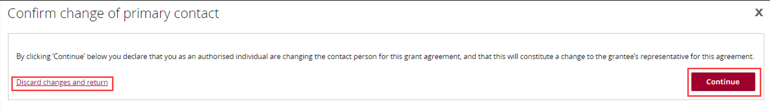
A success message will appear.
The contact will now show Yes under Primary Agreement Contact.
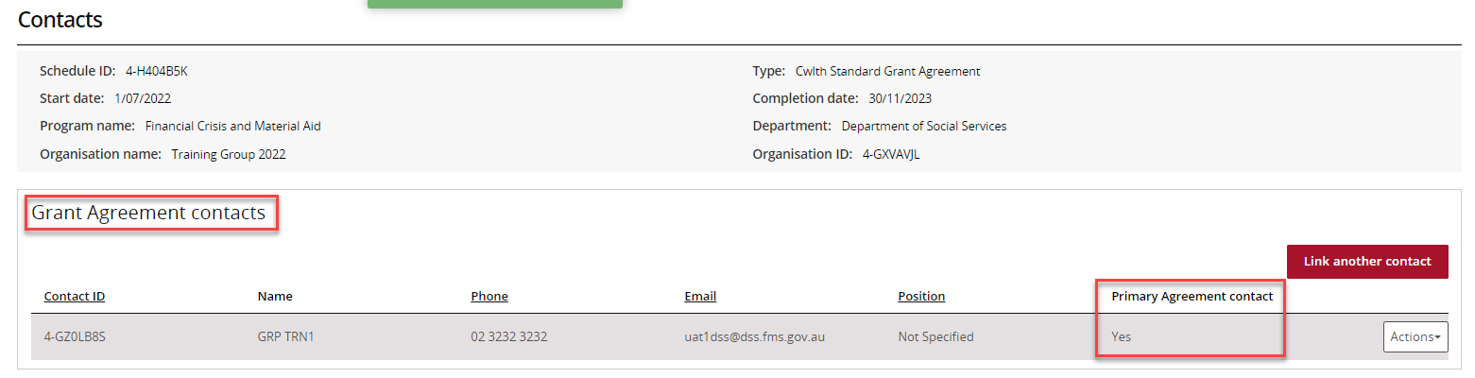

Remove a Contact through Grant Agreements
From the Contacts screen:
- Select Actions beside the contact.
- Select Remove contact from Agreement.

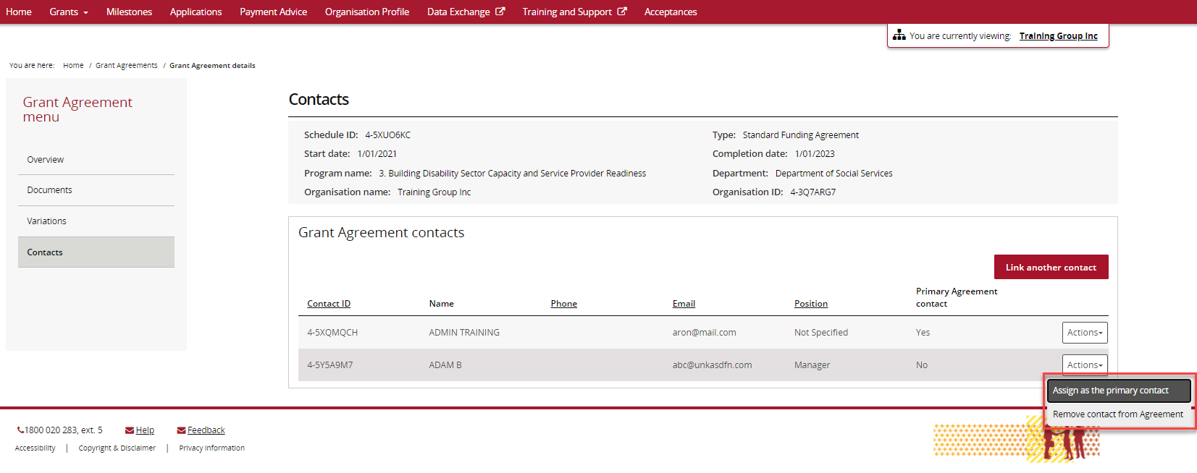
A confirmation window will appear.
Select Yes remove as Agreement contact.
Select Cancel if you do not wish to proceed.
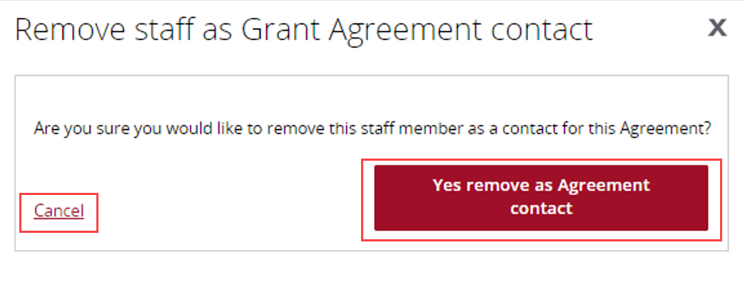
A success message will appear, and the contact will be removed from the agreement.
If the contact is currently the primary contact, an error message will display advising that another primary contact must be assigned first.
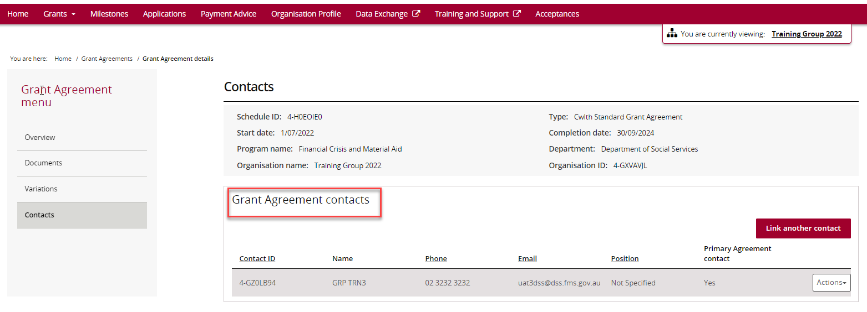
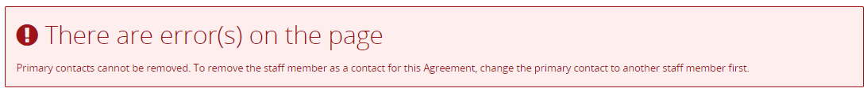

Need help?
For further assistance with the Grant Recipient Portal, please contact the Community Grants Hub at GRP.Helpdesk@communitygrants.gov.au.

