

Grant Recipient Portal Quick Start Guide
  - User Guide
This guide explains how to set up your Digital ID, link it to your organisation, request access to the Grant Recipient Portal (Portal) and log in for the first time.
Portal access required: Administrator, Editor, or View Only.

Quick Links
Before You Start
Set Up Your Digital ID
Link Your Digital ID to Your Organisation
Request Access to the Portal
Login to the Portal
Need help?

Before You Start
The Grant Recipient Portal (Portal) uses the Australian Government Digital ID System to verify users. Digital ID is a safe, secure, and convenient way to prove who you are online.
To discuss alternate methods to manage your grant offline, please email the GRP Helpdesk.
Before you can access the Portal, you must:
- Set up a Digital ID (myID).
- Link your Digital ID to your organisation through Relationship Authorisation Manager (RAM).
- Request access to the Grant Recipient Portal.
- Sign in using myID.

Set Up Your Digital ID
myID is the Australian Government's Digital ID app.
To set up myID:
- Download the myID app from the Apple App Store or Google Play Store.
- Follow the instructions in the app to create your Digital ID.
- Use your personal email address when setting up myID.
Do not use a shared mailbox or work email address.
More information about setting up myID is available on the myID website.

Link Your Digital ID to Your Organisation
Relationship Authorisation Manager (RAM) allows you to act online on behalf of your organisation.
If you are the Principal Authority
Usually the CEO, Director or business owner.
You need to:
- Link your Digital ID to your organisation's ABN in RAM.
- Authorise other staff who need access to government online services.
If you are another staff member
You must be authorised by:
- The Principal Authority, or
- An Authorisation Administrator.
Once authorised, you will receive an email from RAM with instructions to complete the link to your organisation.
More information about accepting an authorisation request can be found on the RAM website.

Request Access to the Portal
The first person given access should generally be the organisation's Administrator.
The Administrator can:
- Manage Portal access
- Create additional users
- Maintain organisation contacts
To request Administrator access:
- Complete the Grant Recipient Portal Access Form.
- Submit the form to the Portal Helpdesk.
Your organisation only needs one Administrator, although additional Administrators can be created if required.
Important: Every user must still have:
- Their own Digital ID, and
- Authorisation to act on behalf of your organisation through RAM.

Login to the Portal
When you have:
- Set up your Digital ID,
- Been linked to the organisation in RAM, and
- Been given Portal access,
go to the Grant Recipient Portal and select Digital ID.
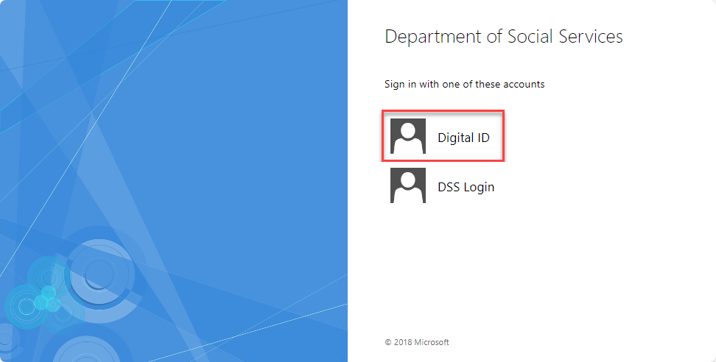
Select myID as your Digital ID provider.
You can also select Remember my choice if you want the Portal to automatically use myID next time.
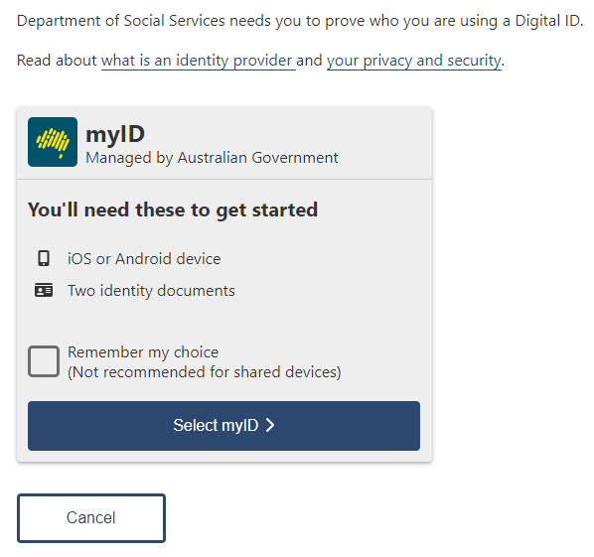
Enter the email address linked to your myID account.
Select Get code.
You can select Remember me to make future logins quicker.
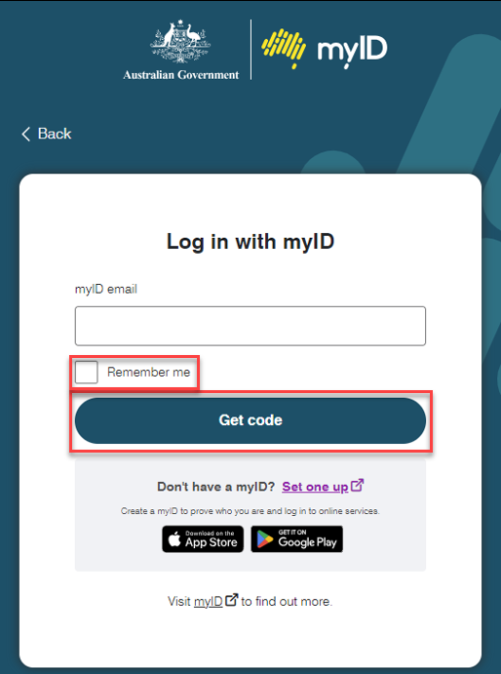
A four-digit code will be displayed on screen.
You will need this code in the next step.
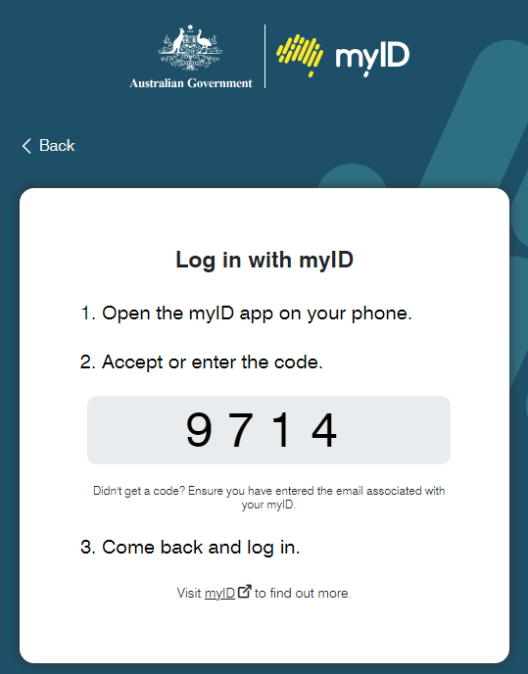
On your mobile device:
- Open the myID app.
- Enter the four-digit code.
- Select Accept.
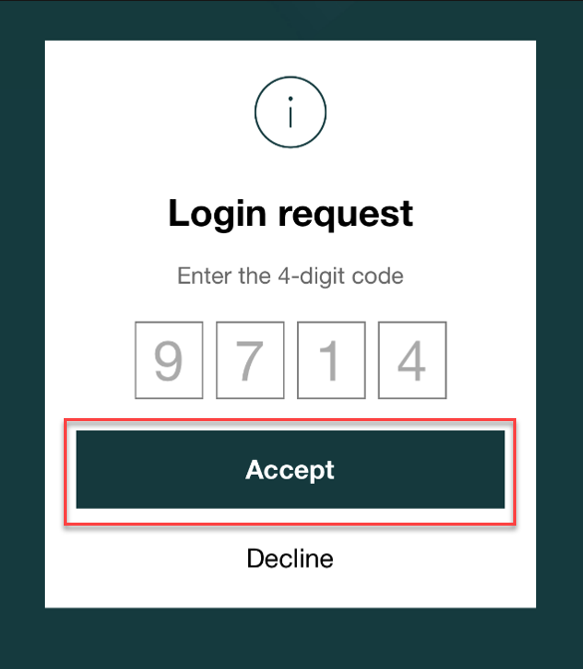
The first time you sign in, you must activate your Portal account.
- Enter the email address used in your Portal access request.
- Select Continue.
An activation code will be sent to your email address.
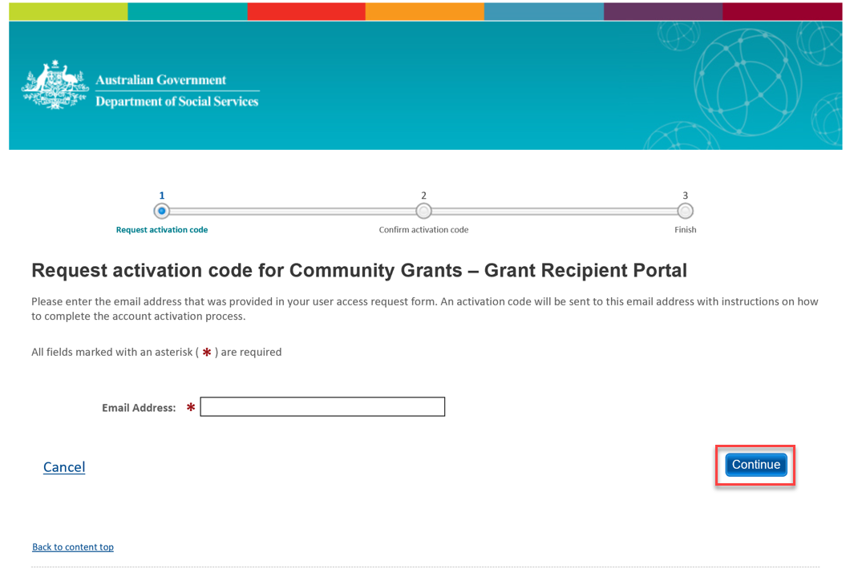
Open the activation email.
Copy the eight-digit activation code.
Enter the code into the Portal.
Select Confirm.
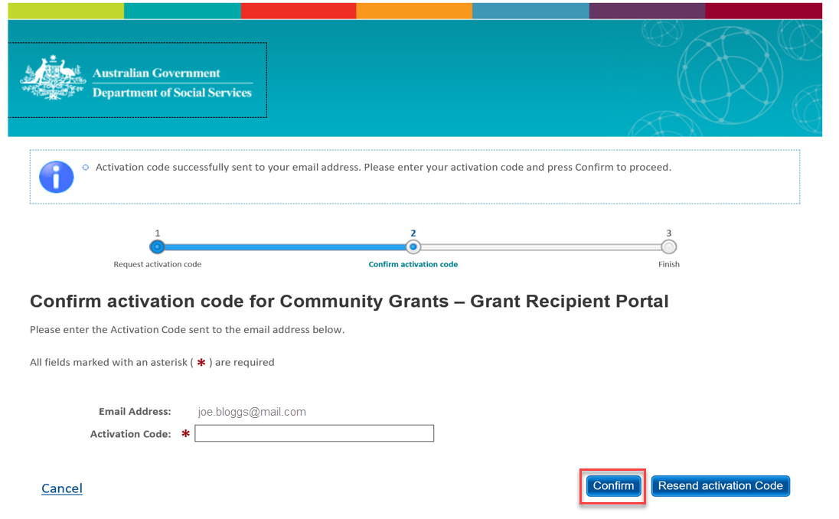
After your activation code is accepted:
- Select Continue.
- Read the terms and conditions.
- Select I Agree.
You will then be logged into the Grant Recipient Portal.
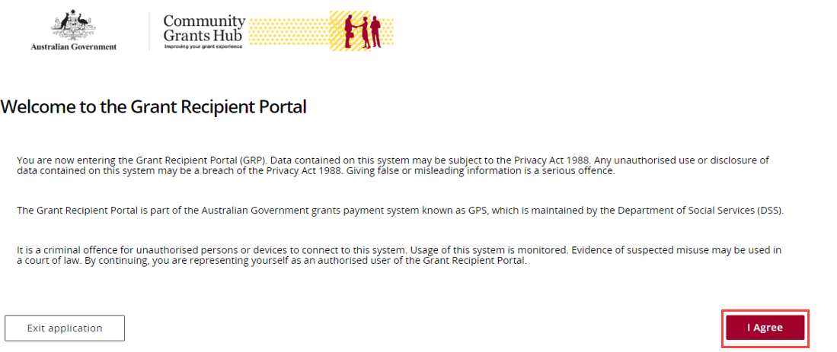

Need help?
For assistance with Digital ID, please see the resources available on the Digital ID and myID websites.
Digital ID | Digital ID System
Home | myID
Phone: 1300 287 539 (Select Option 2, then option 1 for myID)
Operating Hours: Monday to Friday 8.00am – 6.00pm (AEST/AEDT)
For assistance with Relationship Authorisation Manager, please visit the RAM website.
Help | Relationship Authorisation Manager
For further assistance with the Grant Recipient Portal, please contact the Community Grants Hub at GRP.Helpdesk@communitygrants.gov.au.

