

View Grant Information
  - Task Card
The Grant Recipient Portal (Portal) allows grant recipients to view information about their grants, including:
- Grant agreements
- Grant agreement documents
- Variations
- Grant activities
- Milestones
- Contacts
- Bank account details
- Financial information
- Funding Arrangement Manager details
This guide explains how to view grant agreement and activity information in the portal.
Portal access required: Administrator, Editor, or View Only.

Quick Links
View Grant Agreements
View and Download Grant Agreement Documents
View and Download Grant Agreement Variations
View Grant Agreement Contacts
View Grant Activities
Need help?

View Grant Agreements
From the Portal home page:
- Select the Grant Agreements tile, or
- Select Grants from the menu and then select Grant Agreements.
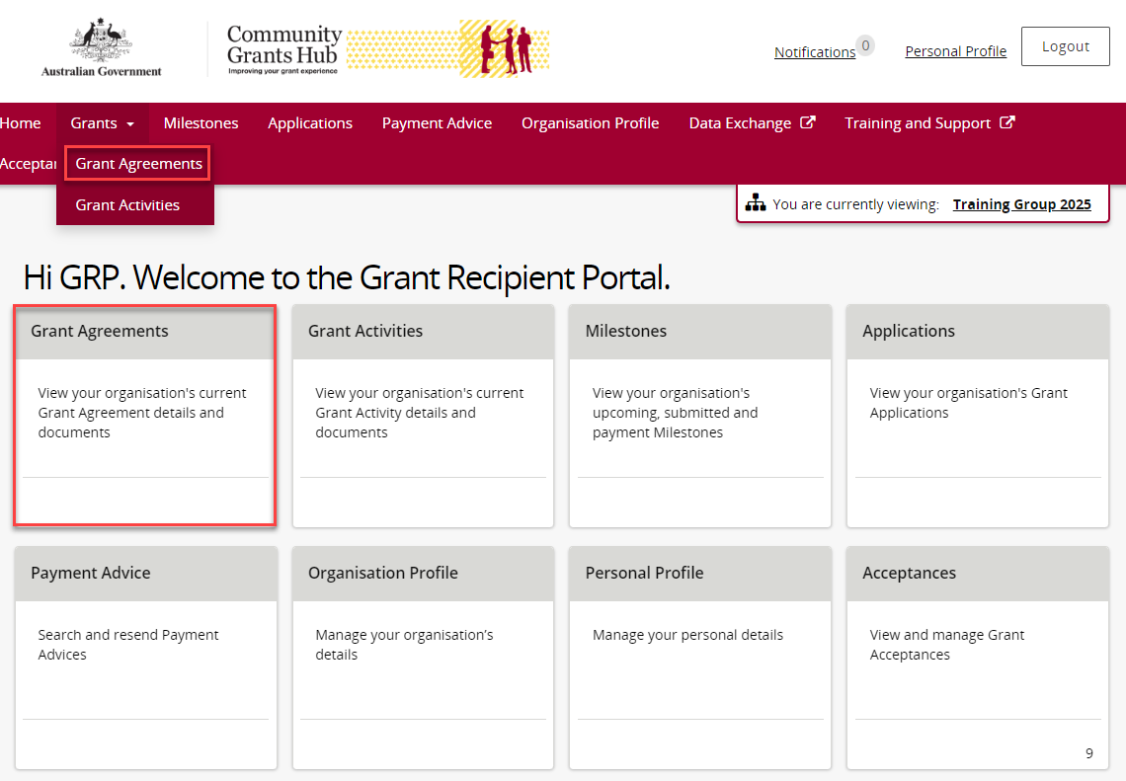
The Grants Agreement screen will display.
Select View beside the grant agreement you want to open.
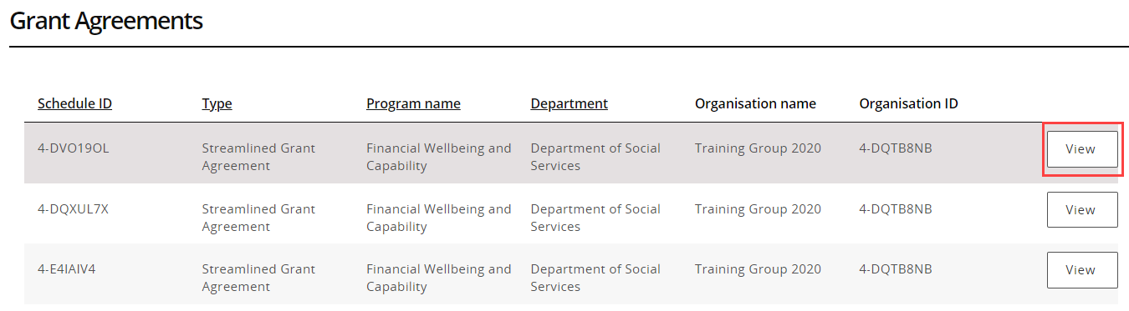
When the Grant Agreement page opens, the Overview section will display.
You can view:
- Schedule ID
- Agreement type
- Start date
- Completion date
- Program name
- Department
- Organisation name
- Organisation ID
The page also displays any grant activities associated with the agreement.
Select View beside the grant activity you want to open.
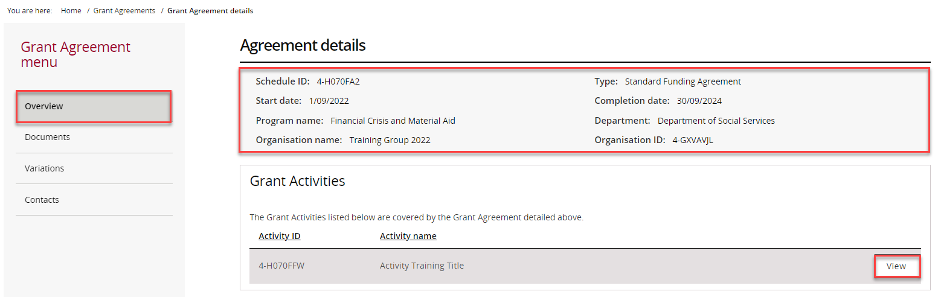

View and Download Grant Agreement Documents
To download grant agreement documents:
- Select Documents from the Grant Agreement menu.
- Review the list of available documents.
- Select View beside the required document.
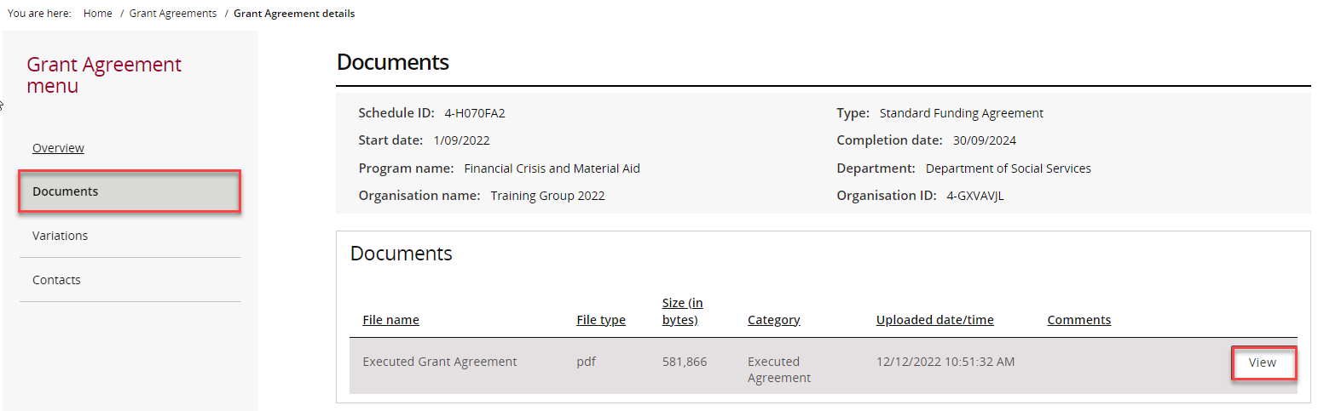
When the download prompt appears, select Download.
The file will be downloaded to your device.
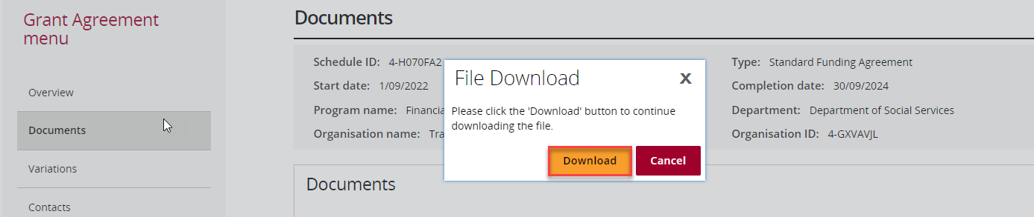

View and Download Grant Agreement Variations
To view variation documents:
- Select Variations from the Grant Agreement menu.
- Select View beside the required variation.
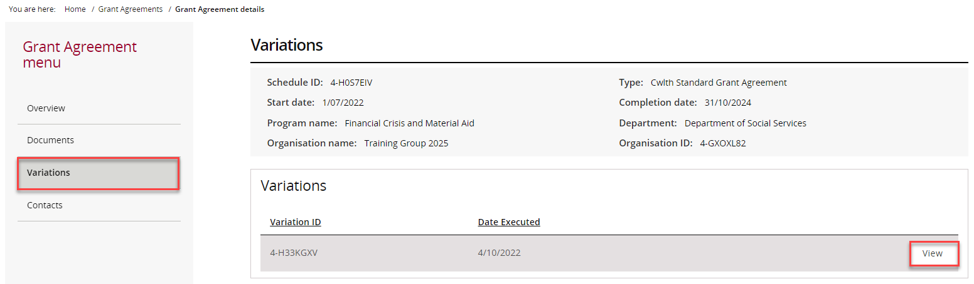
In the pop-up window, select View.
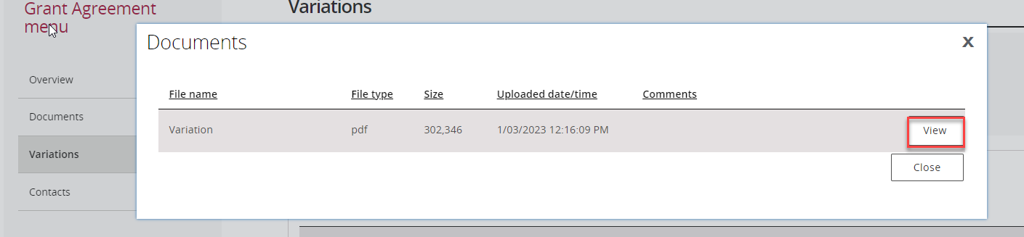
When the download prompt appears, select Download.
The file will be downloaded to your device.
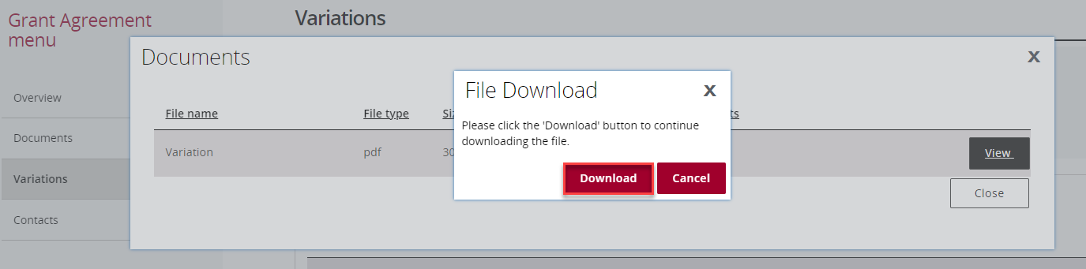

View Grant Agreement Contacts
To view contacts associated with a grant agreement, select Contacts from the Grant Agreement menu.
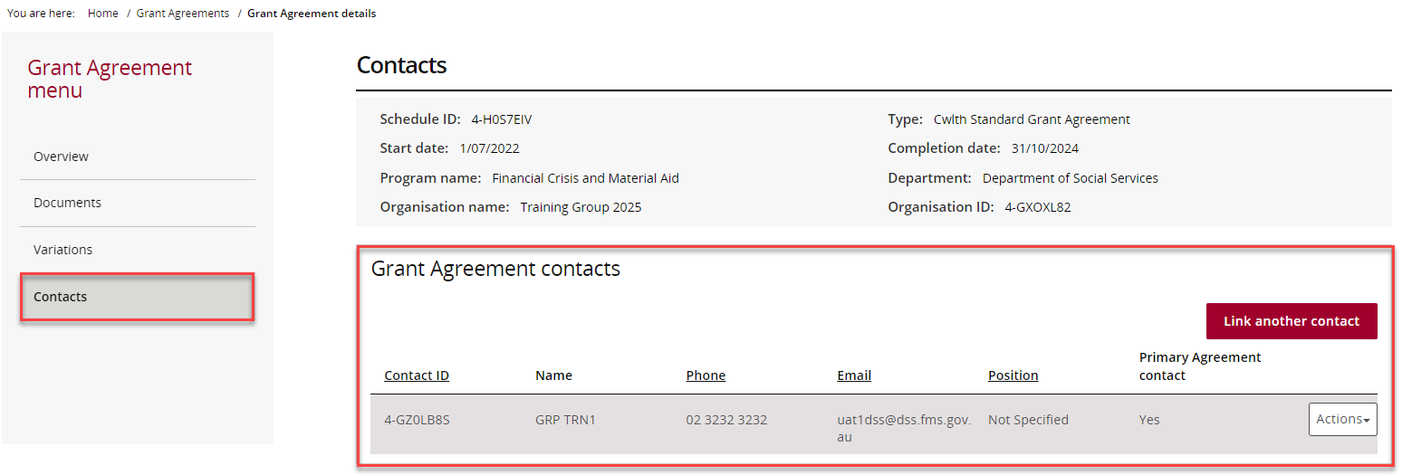

View Grant Activities
From the Portal home page:
- Select the Grant Activities tile, or
- Select Grants from the menu and then select Grant Activities.
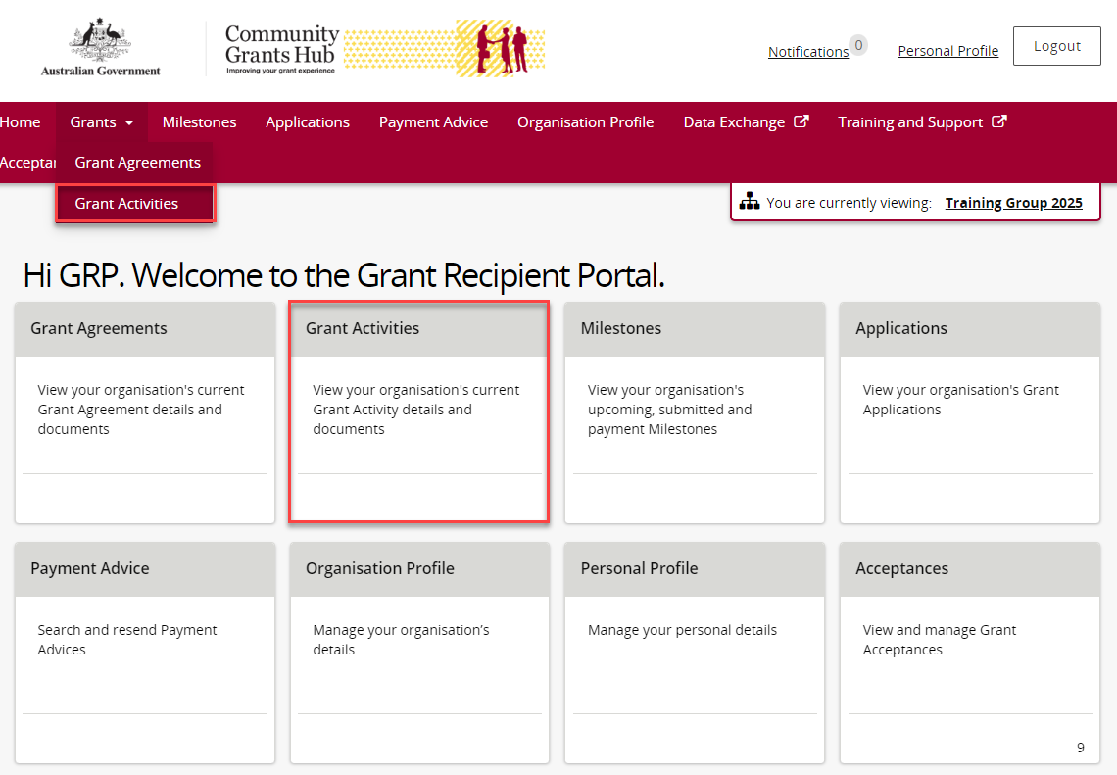
The Grant Activities page will display.
To expand activity information, select the Expand Activity arrow beside the Activity ID.
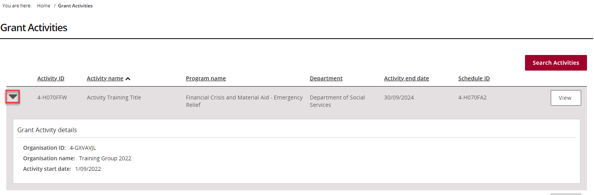
To view details for a specific activity, select View.
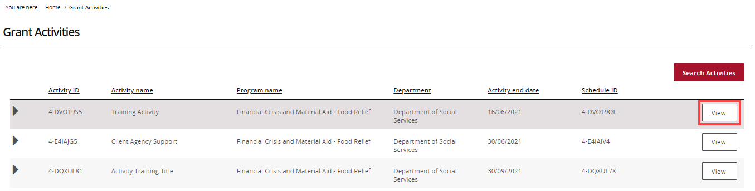
When the Grant Activity page opens, the Overview section will display.
You can view:
- Activity name
- Activity ID
- Program name
- Schedule ID
- Organisation name
- Organisation ID
- Activity start date
- Activity end date
- Department
- Funding Arrangement Manager details
Additional sections available in the menu include:
- Milestones
- Finances
- Bank account details
- Contacts
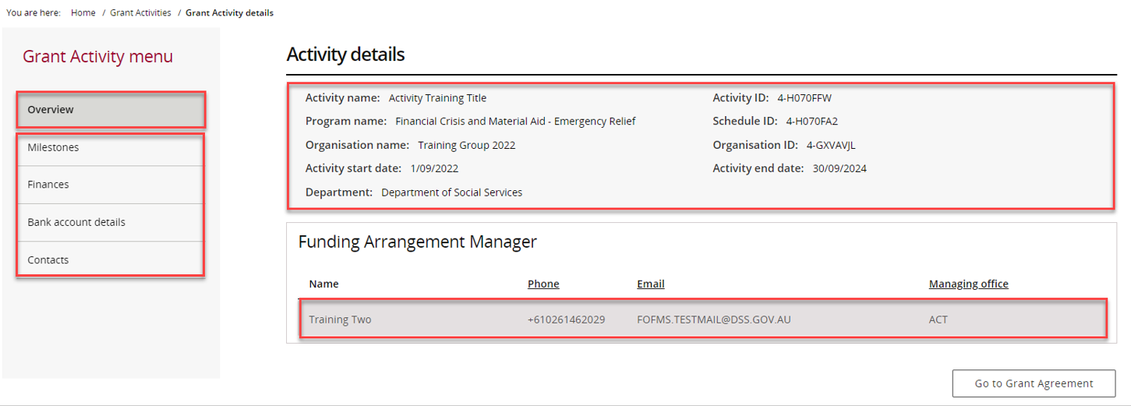
To open the grant agreement linked to the activity, select Go to Grant Agreement.
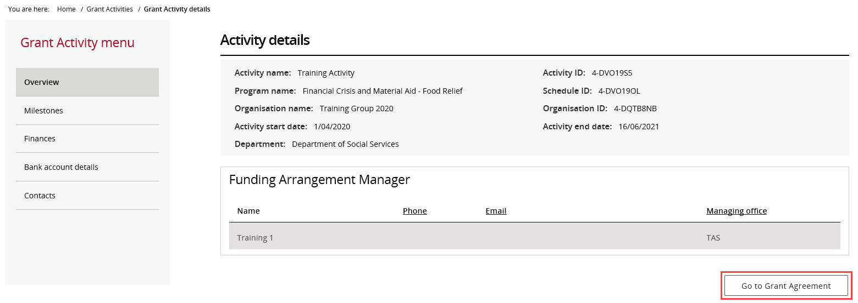

Need help?
For further assistance with the Grant Recipient Portal, please contact the Community Grants Hub at GRP.Helpdesk@communitygrants.gov.au.

