

View Applications
  - Task Card
The Grant Recipient Portal (Portal) allows grant recipients to view a list of submitted grant applications.
If you require a copy of a submitted application, contact the Community Grants Hub.
This task card explains how to view submitted grant applications in the Portal.
Portal access required: Administrator, Editor, or View only.

View Grant Applications
From the Home screen select the Applications tile or select the Applications link from the Navigation menu.
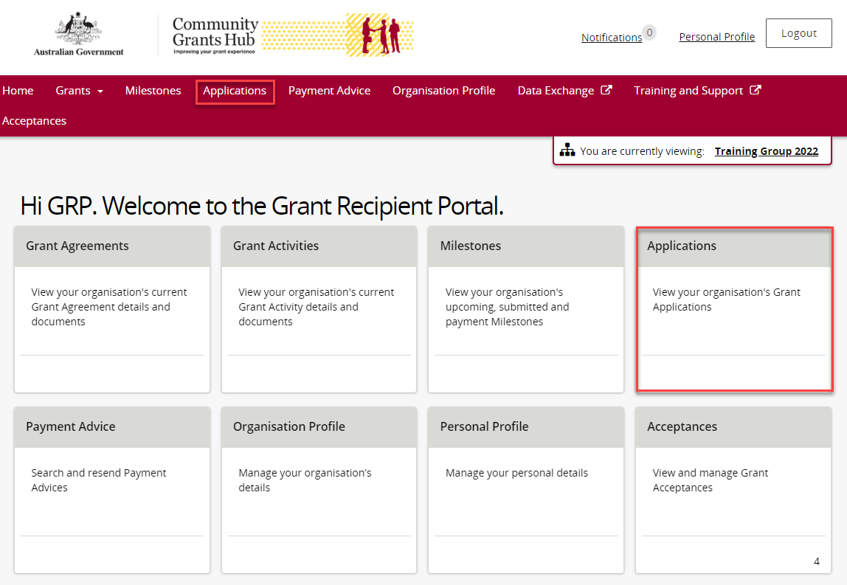
The Applications screen will display a list of submitted applications with the following information:
- Application ID
- Funding Round Name
- Department
- Funding Round Category
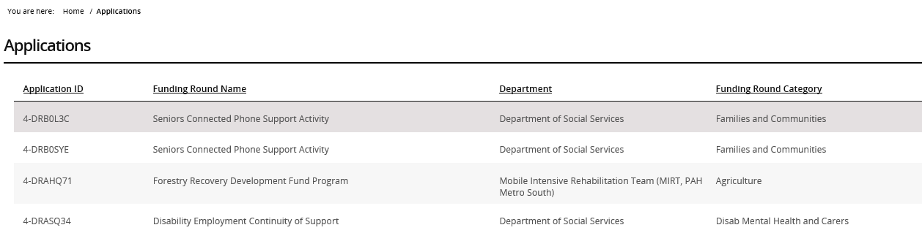

Need help?
For further assistance with the Grant Recipient Portal, please contact the Community Grants Hub at GRP.Helpdesk@communitygrants.gov.au.

