

Update Bank Account Information
  - Task Card
The Grant Recipient Portal (GRP) allows administrators to:
- View bank account details
- Update a bank account name
- Link bank accounts to grant activities
- Request a new bank account
This guide explains how to manage your organisation's bank account information in the portal.
Access Required: Administrator

Quick Links
Update a Bank Account Name
Link a Bank Account to Grant Activities
Request a New Bank Account
Need help?

View Bank Accounts
From the Home page:
- Select the Organisation Profile tile, or
- Select Organisation Profile from the navigation menu.
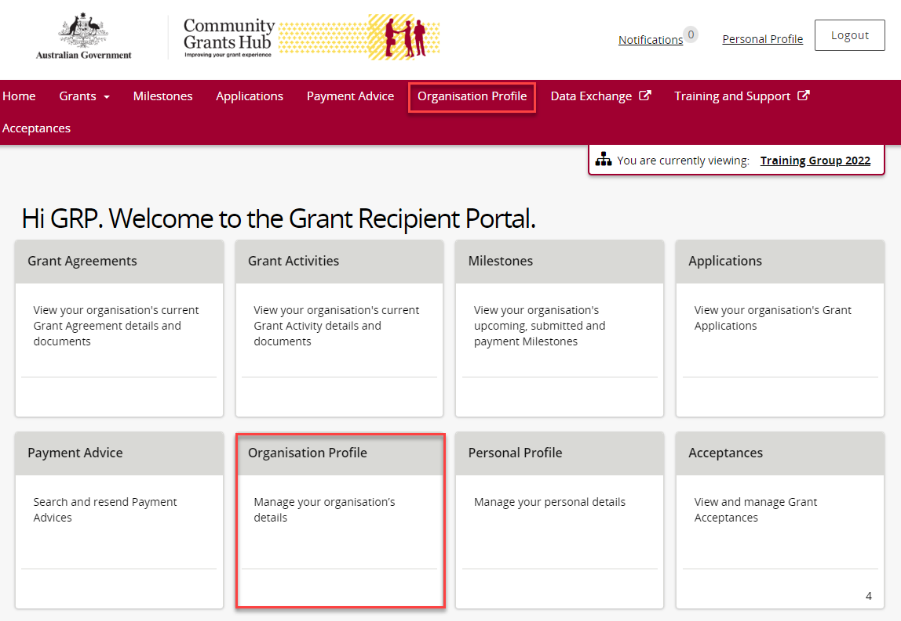
In the Organisation Profile menu:
- Select Bank accounts.
- The list of your organisation's bank accounts will display.
- Select View to see details of a bank account.
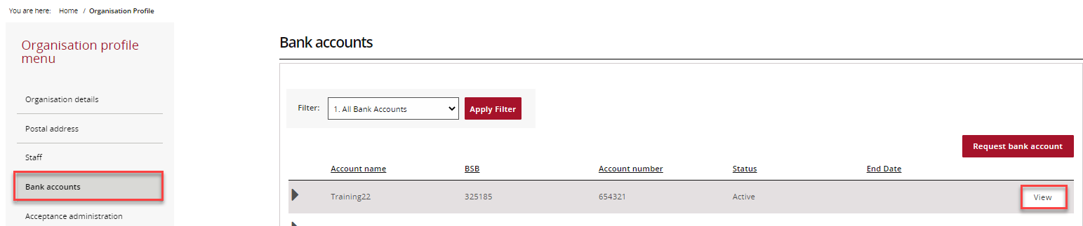
The Bank account details page shows:
- Account information
- Grant activities linked to the account
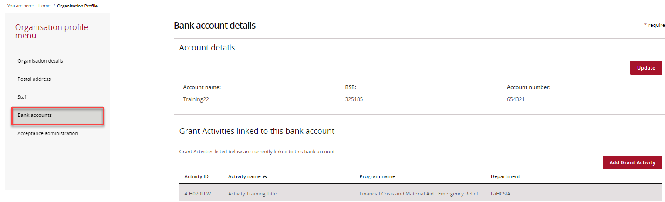

Update a Bank Account Name
From the Bank accounts page, select View next to the account you want to update.
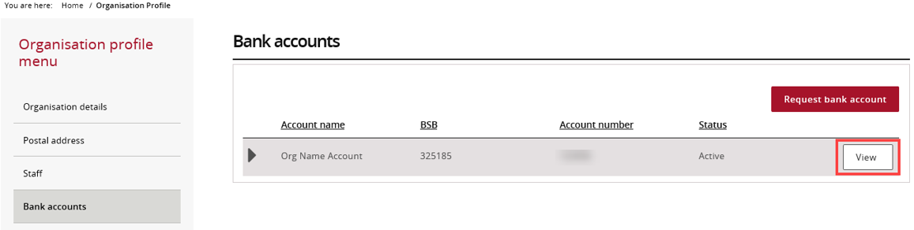
On the Bank account details page, select Update.
Important: You can only change the account name. The BSB and account number cannot be changed. If these details need to change, you must request a new bank account.
Navigate to Bank Accounts
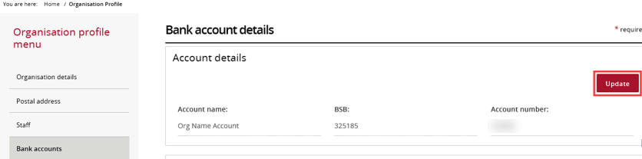
- Update the account name.
- Complete any required fields marked with an asterisk (*).
- Select Save and return.
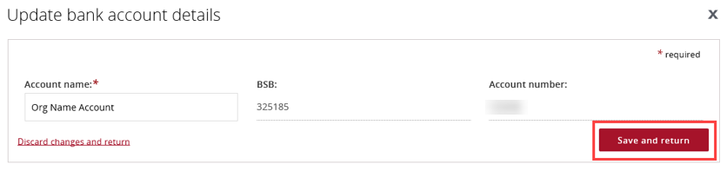

Link a Bank Account to Grant Activities
From the Bank accounts page, select View next to the relevant bank account.
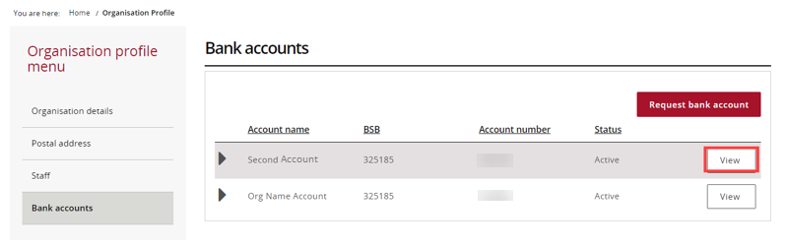
On the Bank account details page, select Add Grant Activity.
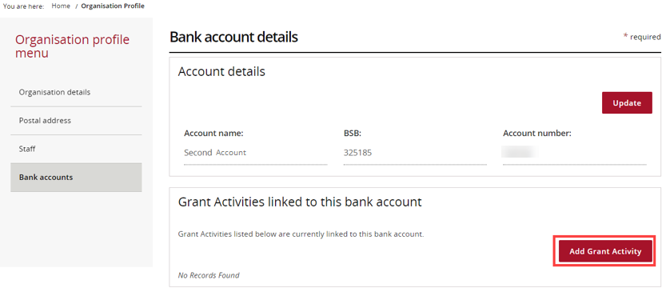
The Link Grant Activities to bank account page displays activities that can be linked to this account.
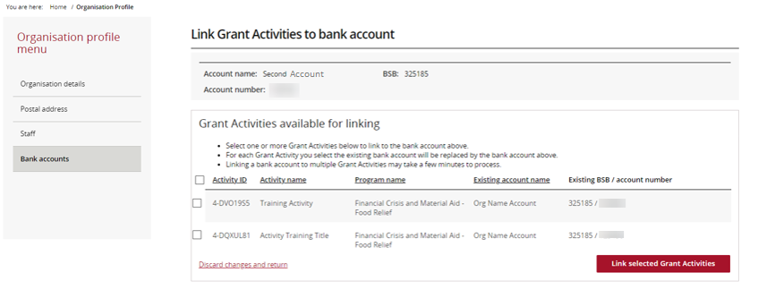
- Select the checkbox next to each activity you want to link.
- Select Link selected Grant Activities.
Tip: To select all activities, use the checkbox next to Activity ID.
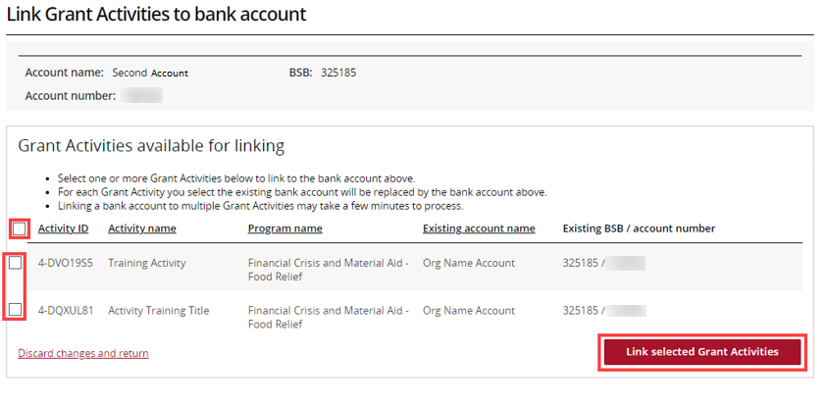
Review the information and select Submit to complete the update.
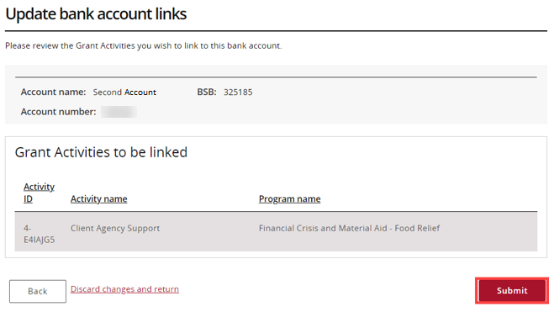

Request a New Bank Account
On the Bank accounts page, select Request bank account.
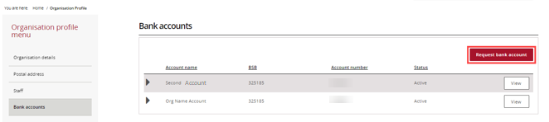
Complete the following fields:
- Account name
- BSB
- Account number
Select Continue.
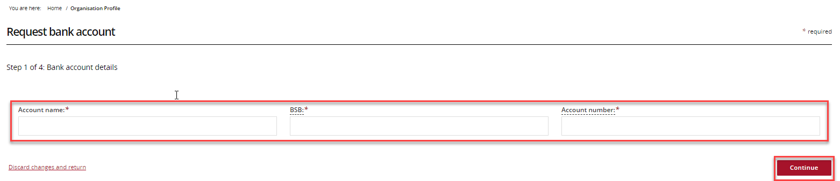
You must provide evidence of the bank account details.
Select Add file and upload a supporting document.
Examples may include:
- A bank statement showing the account name, BSB and account number
- Bank account details included in a grant agreement
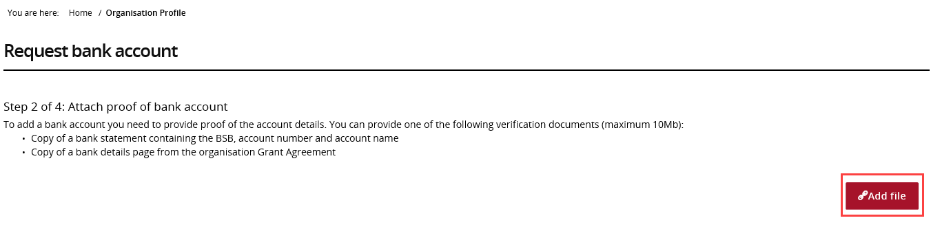
After uploading a file, select Actions to:
- View the file
- Delete the file
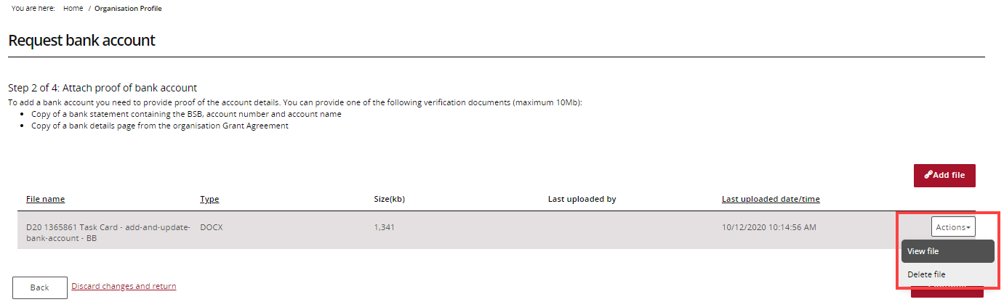
Select Continue to proceed.
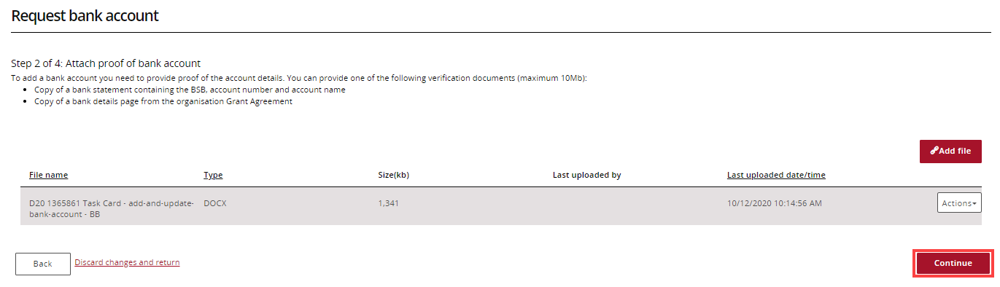
Select the activities that will use the new bank account.
Select Continue.
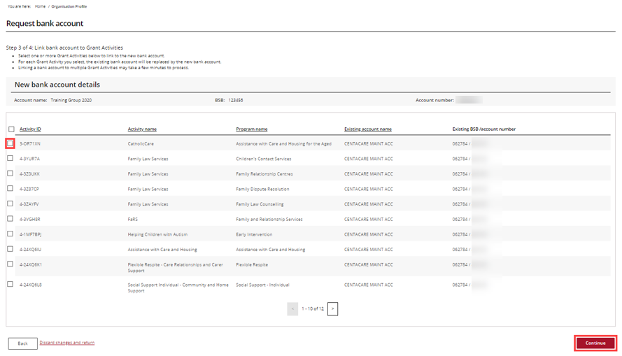

Review:
- Bank account details
- Uploaded evidence
- Linked grant activities
If everything is correct, select Submit.
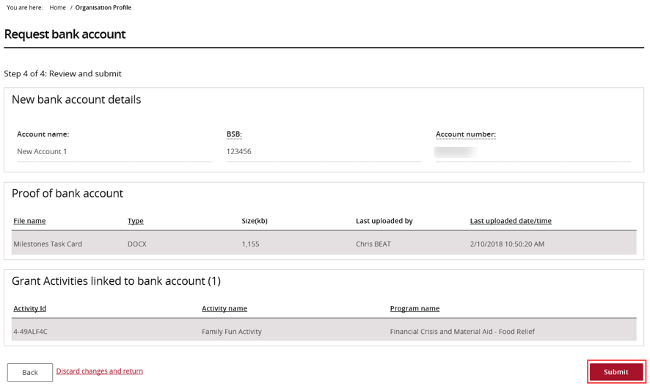
Your request will be sent to the Community Grants Hub for review and approval.
If more information is needed, contact the Funding Arrangement Manager listed in your Grant Agreement.

Need help?
For further assistance with the Grant Recipient Portal, please contact the Community Grants Hub at GRP.helpdesk@communitygrants.gov.au.

