

Update Organisational Information
  - Task Card
The Grant Recipient Portal (Portal) allows administrators to view and manage their organisation's details. This includes updating contact information and postal addresses.
Portal access required: Administrator.

Quick Links
View Organisation Profile
Update Organisation Details
Update Postal Address
Need help?

View Organisation Profile
From the Portal home page, select the Organisation Profile tile, or link from the navigation menu.
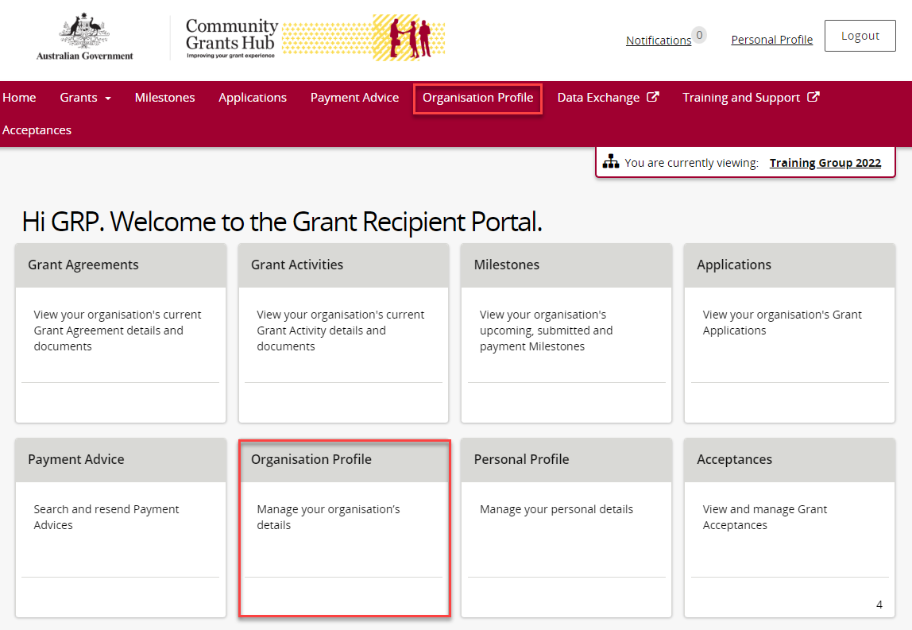
The Organisation Profile page displays information about your organisation, including:
- Organisation ID
- Organisation name
- Legal name
- ABN
- Business address
- Phone number
- General email address
- Financial email address
- Website address
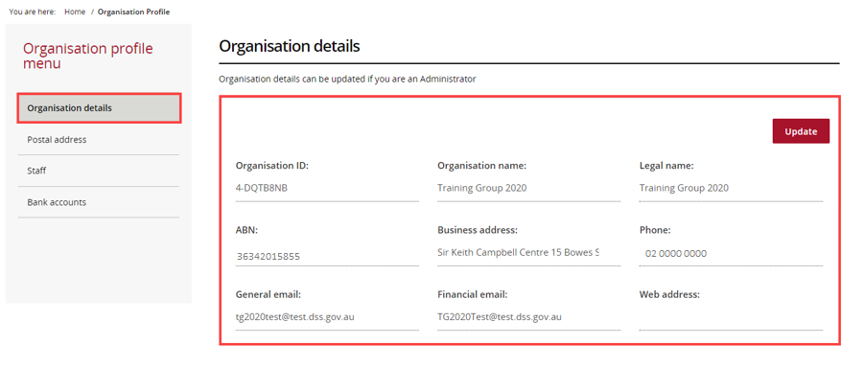

Update Organisation Details
On the Organisation Details page, select Update.
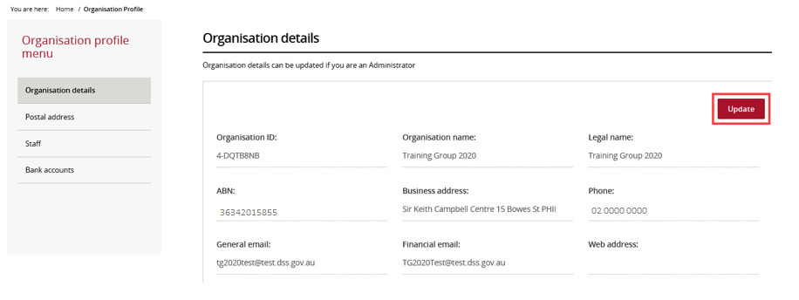
You can update:
- Phone number
- General email address
- Financial email address
- Website address
Note: Your organisation name, legal name, ABN, and business address are linked to your ABN and cannot be changed in the portal.
To update these details, contact your Contract Manager. If you do not know who your Contract Manager is, check the Grant Activity details screen.
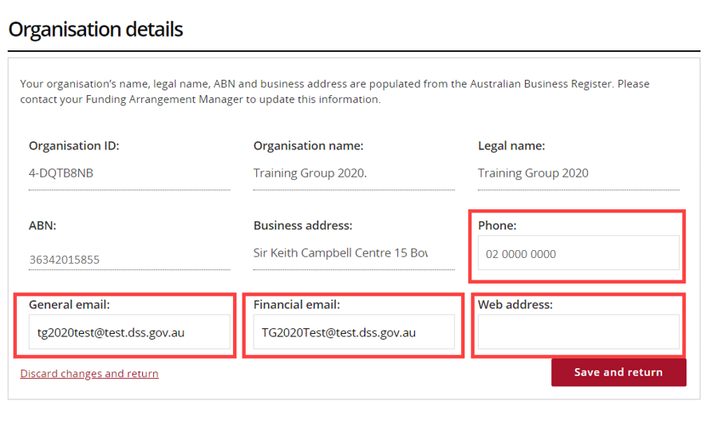
Select Save and return to save your updates.
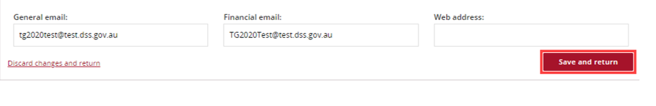

Update Postal Address
From the Organisation Profile menu, select Postal address.
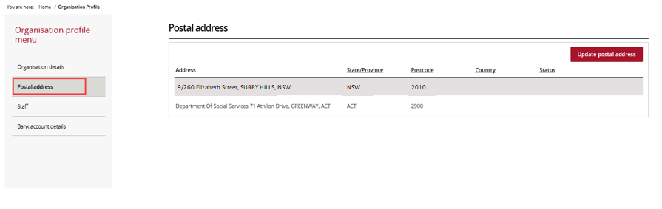
On the Postal Address page, select Update postal address.
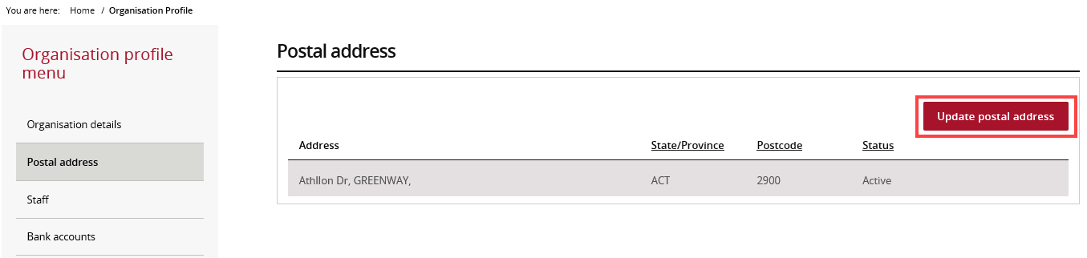
Start typing your new postal address in the address field.
A list of matching addresses will appear as you type.
- Select the correct address from the list.
- Select Save to update your address.
If you cannot find your address, select I don't see my address.
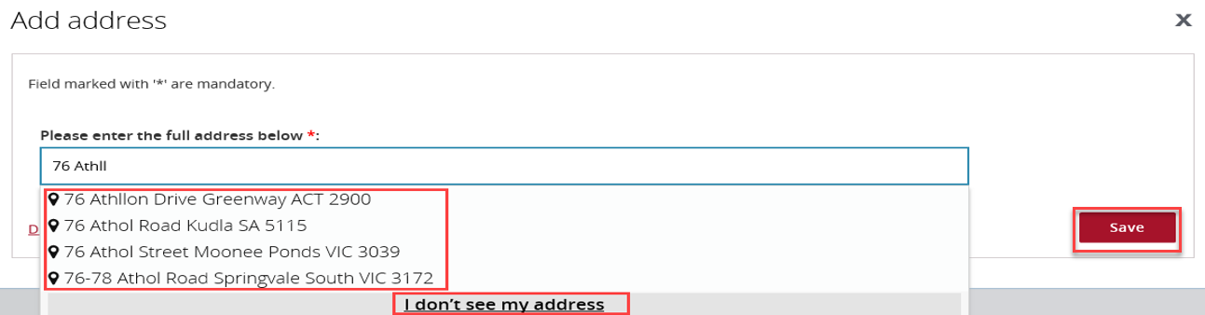
If your address is not listed, enter it manually.
- Complete all required fields marked with a red asterisk (*).
- Select Save when you have finished.
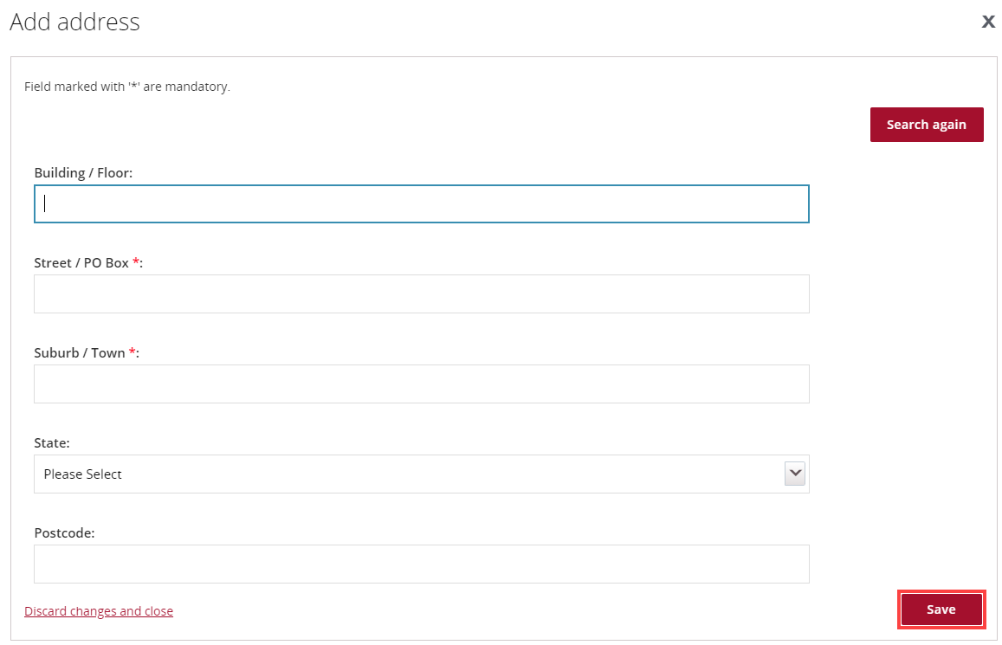

Need help?
For further assistance with the Grant Recipient Portal, please contact the Community Grants Hub at GRP.Helpdesk@communitygrants.gov.au.

