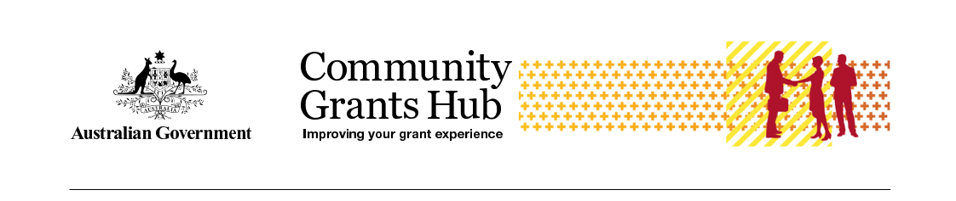

Update your Personal Profile
  - Task Card
The Grant Recipient Portal (Portal) enables grant recipients to view and self-manage their Personal Profile information.
Grant recipients can also select which Organisation information to view in situations where users have access to multiple organisations.
This task card describes the process of updating a Personal Profile and selecting an Organisation to view.
Portal access required: Administrator, Editor, or View Only.

Quick Links
View Your Personal Profile Details
Edit Your Profile
Change the Organisation You Are Viewing
Need help?

View Your Personal Profile Details
From the Portal home page, select the Personal Profile tile, or link from the navigation menu.
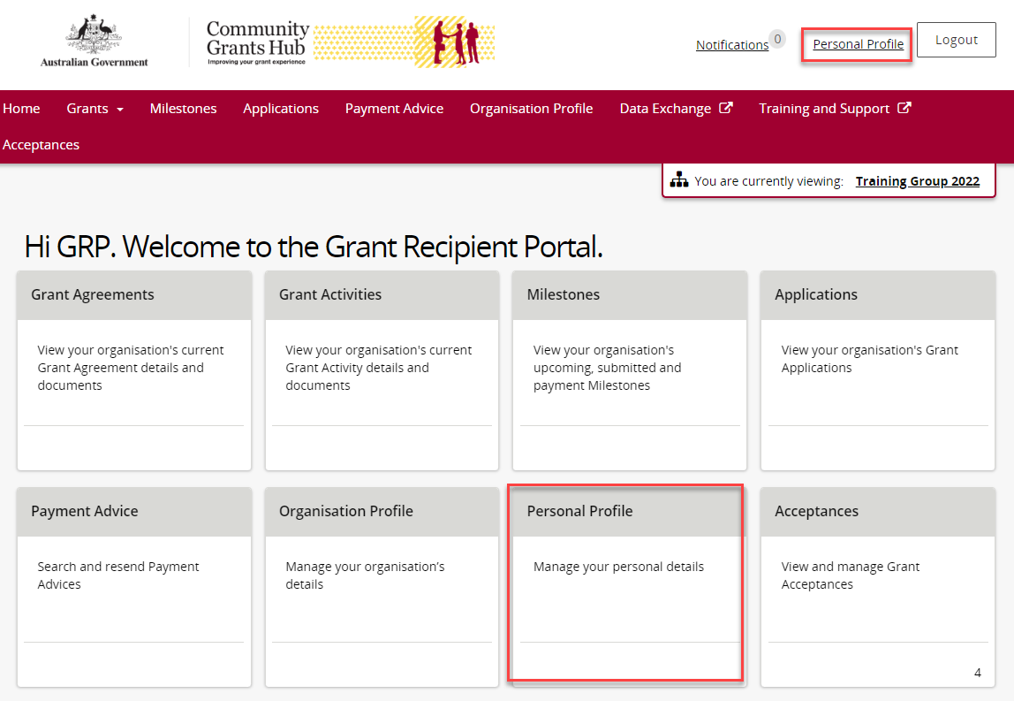
The Personal Profile page contains two sections:
- Personal Profile
- Organisation Selection
In Personal Profile, you can view:
- First Name
- Last Name
- Job Title
- Work Phone
- Mobile Number
- Email Address
- Preferred Communication Method
- Contact ID
In Organisation Selection, you can view the organisations you can access.
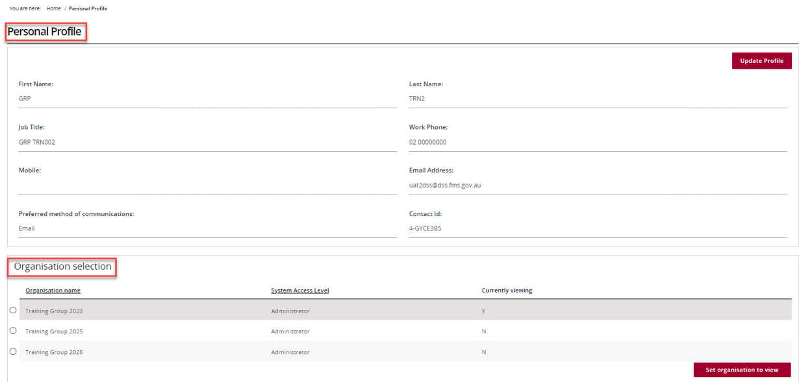

Edit Your Profile
Select Update Profile.
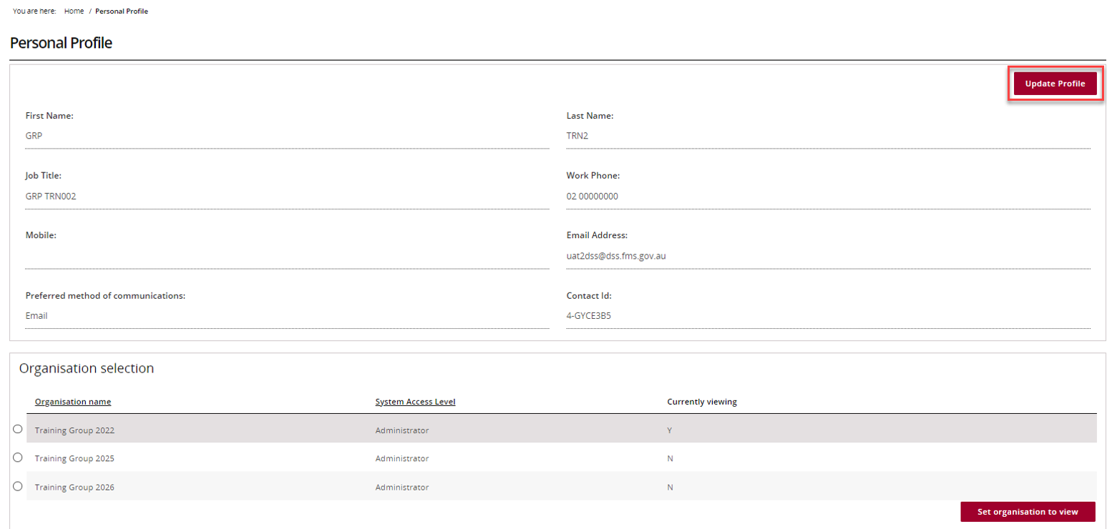
On the Update Personal Profile page:
- Complete all mandatory fields marked with an asterisk (*).
- You can update:
  - Job Title
  - Preferred Communication Method
  - Mobile Number
  - Work Phone Number
After making your changes, select Save.
Note: Other profile fields are linked to your account access and cannot be changed in the Portal. If you need these details updated, contact the Portal Helpdesk.
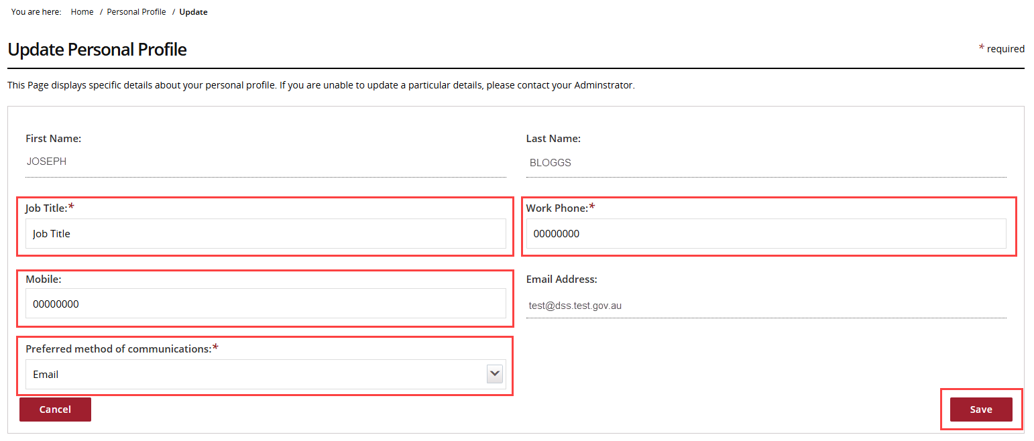

Change the Organisation You Are Viewing
In the Organisation selection section, you will see all organisations you can access.
Note: Some users may have access to more than one organisation.
If you need access to an organisation with a different ABN, you must have:
- A separate Portal account, and
- Authorisation to access the other organisation through Relationship Authorisation Manager (RAM).
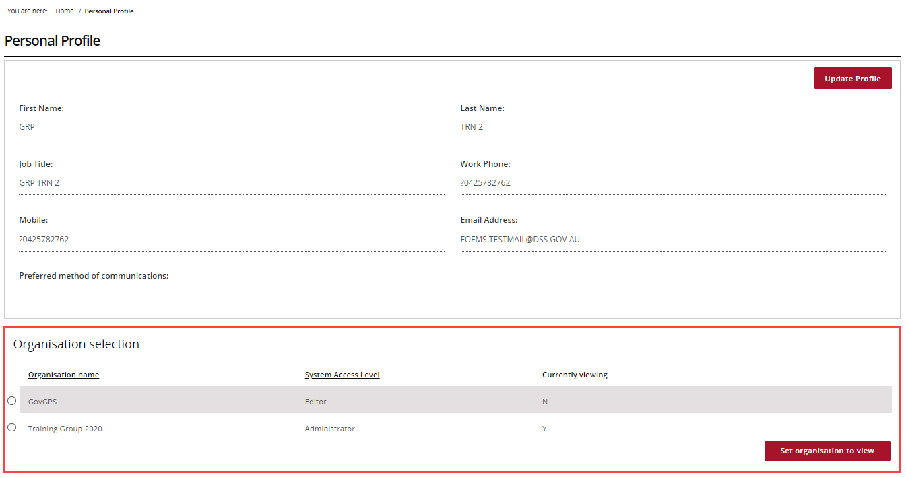
To change organisations:
- Select the organisation you want to view.
- Select Set organisation to view.
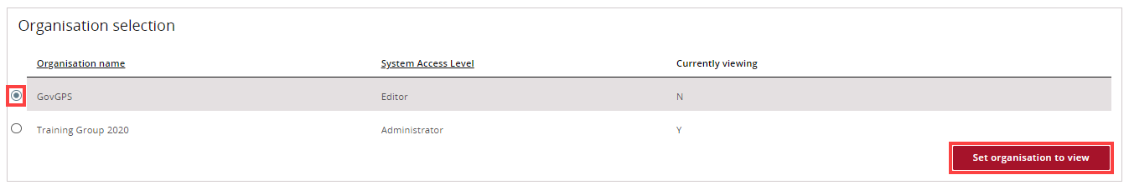
The organisation you are currently viewing will have Currently Viewing as Y.
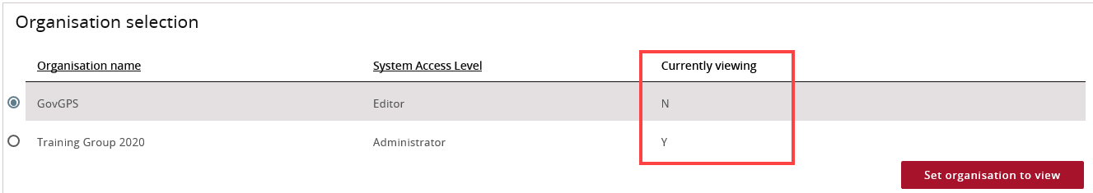

Need help?
For further assistance with the Grant Recipient Portal, please contact the Community Grants Hub at GRP.Helpdesk@communitygrants.gov.au.

